



**Information System (CC4057NP)**

**Sandip Dhakal**

**Course Work**

**GROUP-C1**

**2024, Autumn**

**Informatics College Pokhara**

|  |  |
| --- | --- |
| **Submitted By -:** | **London Met ID -:** |
| **AVIYAN THAPA** | **24040812** |
| **BIBEK POUDEL** | **24041079** |
| **KRITESH DHAREL** | **24042043** |
| **RAHIL KUNWAR** | **24044059** |
| **UNITA RAI** | **24044450** |

**February-02, 2025**

**Table of Contents**

1. Introduction 6

1.1 Aims & Objectives 6

1.2 Tools Used 7

a) HTML 7

b) CSS 9

c) JavaScript 13

1.3 Verdict 15

2. Discussion and Analysis 16

2.1 Visual Studio Code 16

2.2 Balsamiq 17

2.3 Microsoft Word 18

2.4 GitHub 18

2.4 Google Chrome 19

3. Wireframe 21

3.1 Home page 21

3.2 Product 23

3.3 Research 26

3.4 Blog 29

3.5 About Us 31

4. Testing 34

4.1 Objective 34

4.2 Types of Testing 34

4.3 Tools Used in Testing 35

4.4 Testing Scope/What we are testing 35

4.5 Functional Testing 35

Test 1 35

Test 2 39

Test 3 40

Test 4 44

Test 5 45

4.6 Compatibility Testing 47

Test 6 47

5. Conclusion 50

6 References 51

7 Appendix 53

7.1 Home Page HTML/CSS 53

7.2 Product Page HTML/CSS 75

7.3 Research Page HTML/CSS 94

7.4 Blog Page HTML/CSS 112

7.5 About Us Page HTML/CSS 124

7.6 Style.css 138

7.7 Script.js 143

**Table of Figure**

Figure 1 : HTML Logo 7

Figure 2 : HTML Sample Code 8

Figure 3 : CSS Logo 9

Figure 4 : Inline CSS Code 10

Figure 5 : Internal CSS 11

Figure 6 : Linking External CSS 12

Figure 7 : External CSS 12

Figure 8 : JS Logo 13

Figure 9 : Internal JS 14

Figure 10 : Linking External JS 14

Figure 11 : External JS 15

Figure 12 : VS Code Logo 16

Figure 13 : Balsamiq Logo 17

Figure 14 : Word Logo 18

Figure 15 : Github Logo 18

Figure 16 : Chrome Logo 19

Figure 17 : Wireframe of Home page of our website 21

Figure 18 : Home page of our website 22

Figure 19 : Wireframe of Product page of our website 23

Figure 20 : Product page of our website 24

Figure 21 : Wireframe of Research page of our website 28

Figure 22 : Research page of our website 28

Figure 23 : Wireframe of Blog page of our website 29

Figure 24 : Blog page of our website 30

Figure 25 : Wireframe of About Us page of our website 31

Figure 26 : About Us page of our website 32

Figure 27 : Entering Correct Mail 36

Figure 28 : Entering In Correct Mail 36

Figure 29 : Missing Colour Changing Statement 37

Figure 30 : Added Colour Changing Statement 38

Figure 31 : Newsletter Success Message Shows In Green Colour 39

Figure 32 : Newsletter Error Message Shows in Red Colour 39

Figure 33 : Showing Thank You when input is not Empty 40

Figure 34 : Shows error when input is empty 40

Figure 35 : Home Page 41

Figure 36 : Product Page 42

Figure 37: Research Page 42

Figure 38 : Blog Page 43

Figure 39 : About Page 43

Figure 40 : Before click back to top button 44

Figure 41 : Result after click back to top 45

Figure 42 : Before Hover 46

Figure 43 : After Hover 47

Figure 44 : Compatibility Testing in EDGE Browser 48

Figure 45 : Compatibility Testing in BRAVE Browser 49

Figure 46 : Compatibility Testing in CHROME Browser 49

**Table of Table**

Table 1 : News Letter Testing Report 35

Table 2 : Newsletter After Bug Fix Report 39

Table 3 : Form Validation Testing Report 40

Table 4 : Navigation Bar Testing Report 41

Table 5 : Back to top button Testing Report 44

Table 6 : Hover Effect Testing Report 45

Table 7 : Browser Compatibility Testing Report 48

Table 8 : Summary of Overall Tests Report 50

# Introduction

The project for the coursework assignment was practically applying our web development skills in designing and developing a static website which develop individual creativity and problem-solving technic. HTML, CSS, JavaScript are the core web technologies used for making this project (Website). The websites is related to the e-commerce sectors for the watch industry. each member of this group has actively done participate in this group course. The Blas Mique is used for designing of this course work. Balsamiq Wireframes is a user interface design tool for creating wireframes (sometimes called mockups or low-fidelity prototypes. Netch watch is the brand name of our projects. the home page contains the path for different section with attractive header and footer with hover effect in navigation bar.it also contains popular brands, new arrival products, discounted price, different types of watch, and highlight the features of watch collection. Product page shows details about particular watches and button for purchasing that watch. Online shopping has brought the shopping experience to their fingertips via desktop and mobile devices, completely changing the way customer shop. Customer can buy product at their ease. Customers can know the answer of where ,how and when to buy the product they wanted (Schultz, 2025). It also have feature to rate the products in this page. research contain Analyze and contrast of the website’s references from other e-commerce platforms. About us contain details of our group member and blog page contains impact of technology on the watch industry and consumer trends.

## 1.1 Aims & Objectives

The motive of the e-commerce for increasing the sales of Netch watches and provide home delivery. This coursework serves as a practical application of our conceptual knowledge. putting into practice the skills acquire in the classroom. The goals and objective may vary according to personal preferences and learning goals, but some common objectives include:

* To Provide service to the user such home delivery, different color and style and others,
* Creating a user-friendly e-commerce for selling different brands watch,
* Show case the details about the products, the materials it has used for each product,
* Creating multiple choice for the user,
* Providing watch with high discounted rate ensuring high quality image and products,
* Distribute the knowledge related to watch,
* Providing different sites such as Instagram, Facebook, Twitter and other social media for personal interaction.

## 1.2 Tools Used

### a) HTML



Figure 1 : HTML Logo

HTML stands for Hyper Text Markup language which is used for structuring presenting the websites to different web-browser. It is the skeleton for websites. Html is a simply text documentation in which .txt is replace by .html. HTML is case sensitive for class and id but not for tags. It is granted by Tim Berners Lee. It can be operated by all the devices and can be view through internet in all around the world. Html 5 is the new and current version of Html. It is used for making websites.HTML is a text file containing specific syntax, file and naming conventions that show the computer and the web server that it is in HTML and should be read as such (W3School, 2025).

By applying these HTML conventions to a text file in virtually any text editor, a user can write and design a basic webpage, and then upload it to the internet. Some of unique HTML tags are:

<marquee>: Used to add a scrolling area in respective format.

<option>: shows an option to select the inserted list.

<del>: represents that it has been excluded from our websites.

<footer>: defines last parts of the site.

<header>: defines a first part of the site.

<div>: defines a portion to group the element.

<a>: used to link another page or site (W3School, 2025).

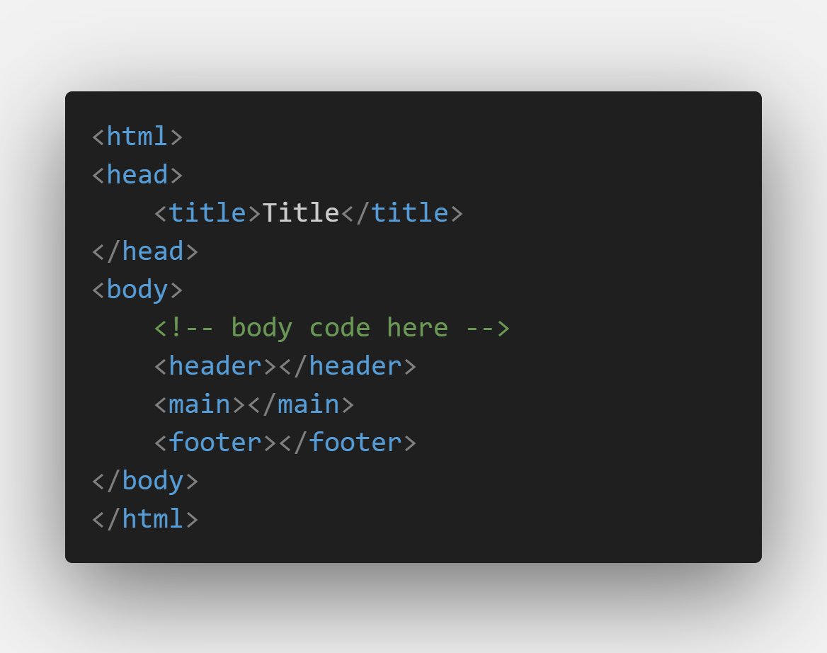

Figure 2 : HTML Sample Code

### b) CSS



Figure 3 : CSS Logo

CSS stands for cascading style sheet which used for styling the websites. It is skin and clothes for the websites. CSS is also a text documentation in which .txt is replace by .CSS. Just like .html. CSS is not Case-Sensitive (except fonts, URLs, etc). It is owned by Haakon Wim Lie. It is basically a stylesheet language which show how to style the html documents and show case it. It design the html elements by using different CSS properties such as color, flex , margin , border and others. It is used to select class and # is used to select id which applies styles to the respective class or id (Geeks for geeks, 2024). This optimization capability also contributes to improved search engine CSS can be used by 3 ways:

**Inline CSS**

Most of the CSS can be written in internal or external CSS. Beside inline CSS can also be used. It is specific for particular class or division. It is written inside html elements. It does not need external files or closing tags for it. It is written in single line therefore, it is knowns as inline CSS. Since it is written in inside html so testing and debugging is easy and quick. In general, this is not prefer as a best practice. In some special condition inline styles is only choice for it. However, there are times when inline styles are the right (or only) choice. Inline CSS has higher precedence (CodecademyTeam, 2025). Following shows the example of inline CSS which showcase for our e-commerce websites:.

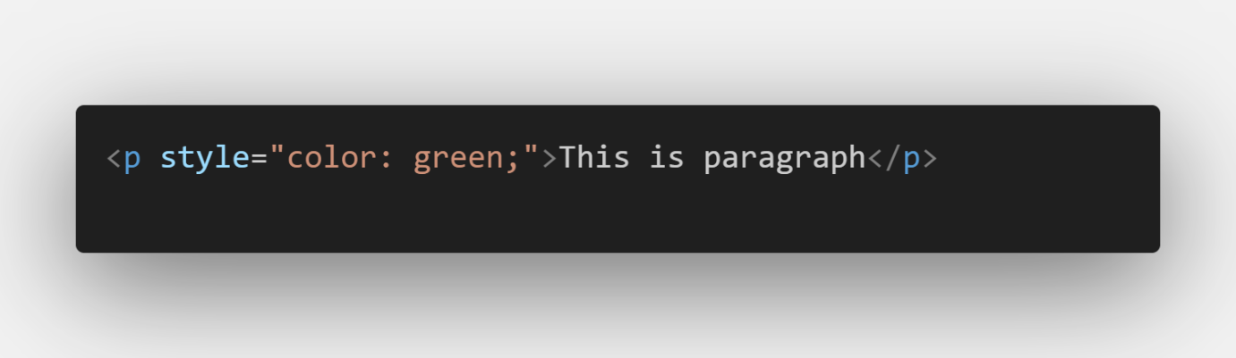

Figure 4 : Inline CSS Code

**Internal CSS**

Internal CSS is used to style the html documents in which one or more code are same to each other within single html documentation. It is basically written inside open and close style tags. It is slow as it takes more time to load after each view. It is easier to manage as no other files are needed (Geeksforgeeks, 2024). Following shows the example of internal CSS which showcase for our e-commerce websites:

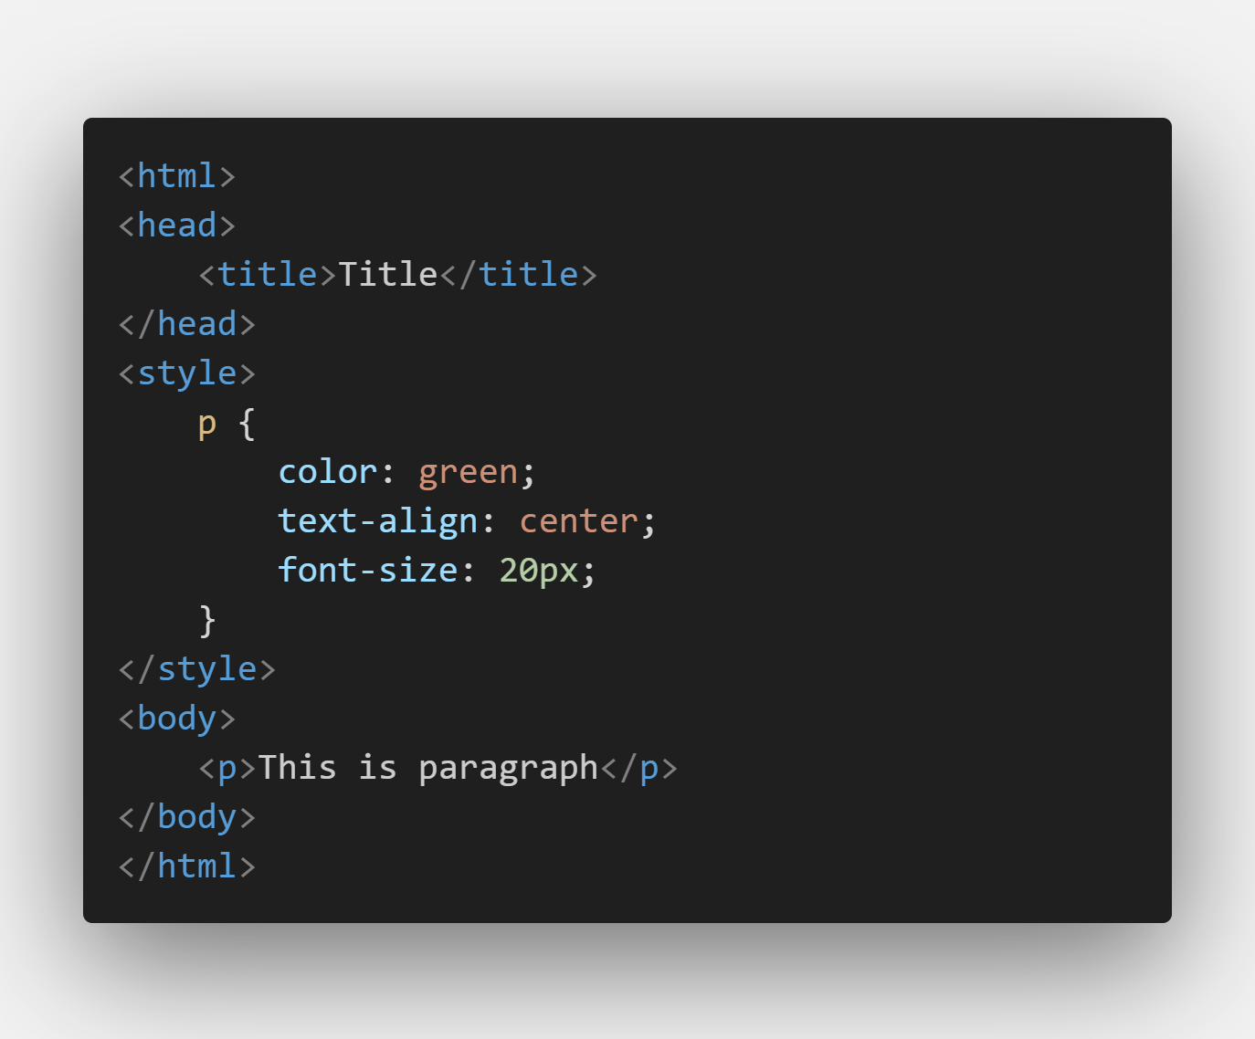

Figure 5 : Internal CSS

**External CSS**

Most of the time for creating websites, external files are used and link it to the html document. It is basically used to for writing the code which have been used one or more html documents. It is very helpful for large project. It is easier to update and manage. External CSS is fast as it takes less time to load after each view. It is link with Html document by link tag (Javatpoint, 2025).

Following shows the example of external CSS which showcase for our e-commerce websites:

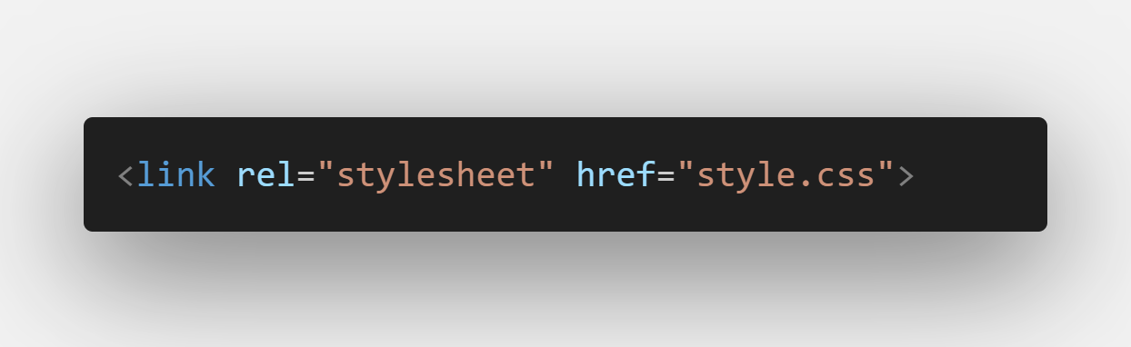

Figure 6 : Linking External CSS

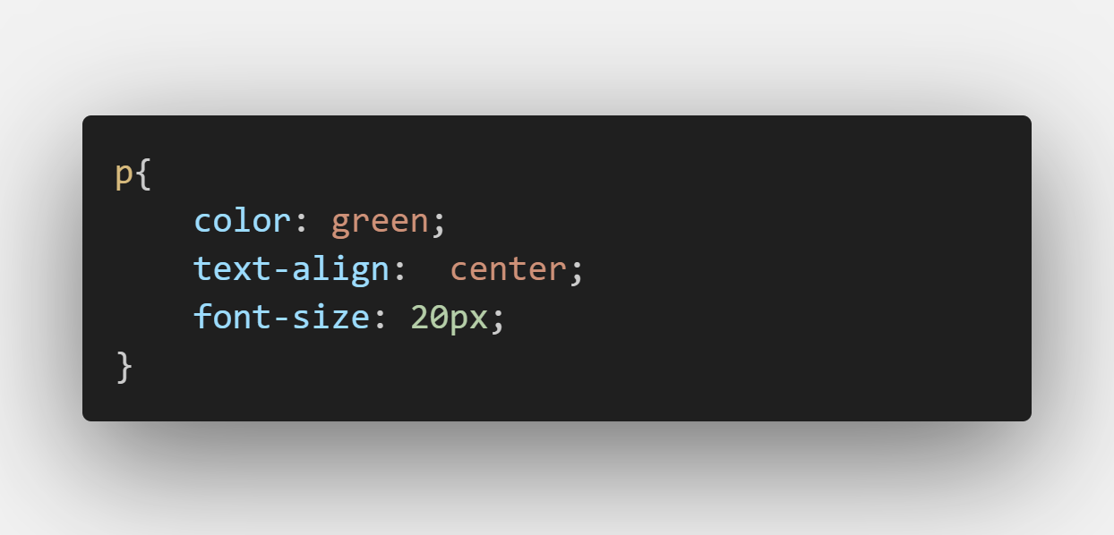

Figure 7 : External CSS

### c) JavaScript



Figure 8 : JS Logo

JS stands for JavaScript which is used for making websites interactive. It is brain and behavior of our websites. It can manipulate both html and CSS code. It can be target to particular element or portion by the help of id. The founder of JS is Brendan Erich. Usually JS is not only for interactive but it can also be used as React, Typescript, Node and others. It is also capable for event handlers such as clicking add to cart button, conditional coding and others. Many browsers use JavaScript as a scripting language for doing dynamic things on the web (Megida, 2021). Usually, JS can be written in two different ways:

**Internal JS**

Internal JS is used write the code within the html documentation with script tags. It is used for writing the code for repeated within the single html documentation. Separate files should not used for it (Geeksforgeeks, 2024). Following shows the example of internal JS which showcase for our e-commerce websites:

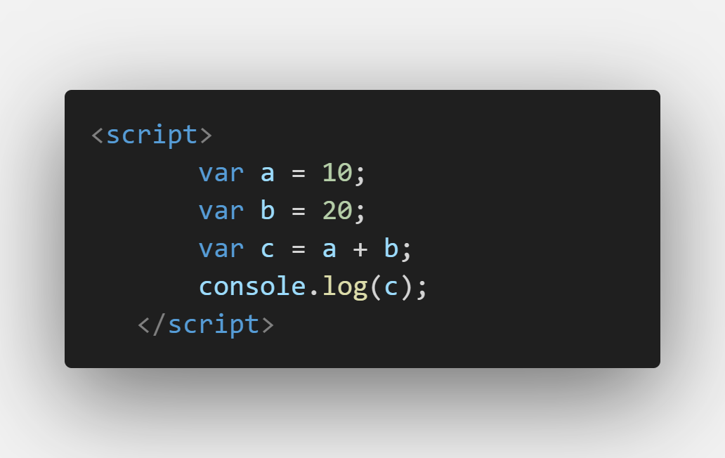

Figure 9 : Internal JS

**External JS**

External JS is used to write the code in separate file which have extension of .JS and link it to the html document. It is basically used for writing code which are repeated for two or more than two html document. It is easy to maintain (Geeksforgeeks, 2024). Following shows the example which we uses in our websites:

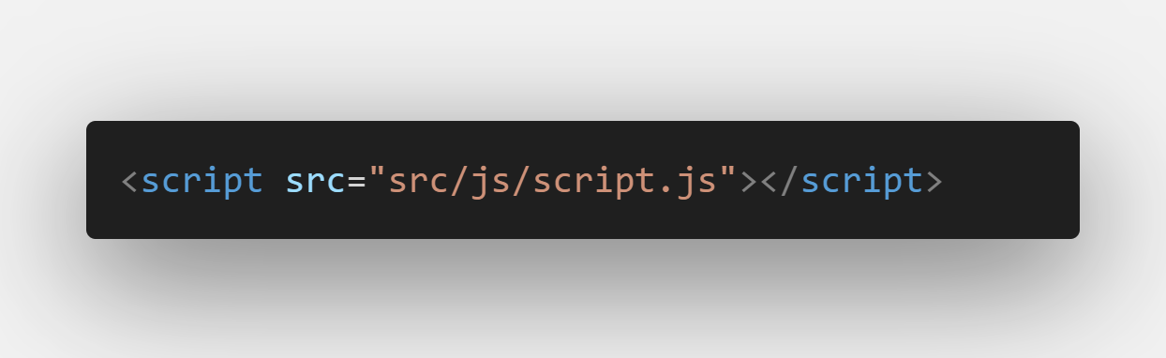

Figure 10 : Linking External JS

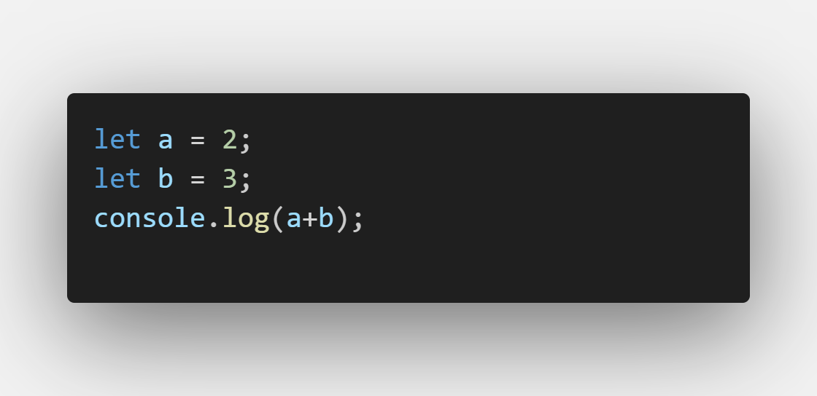

Figure 11 : External JS

## 1.3 Verdict

While designing the websites we faced different features in creating the websites such as discounted price, customer service, and others. Netch watches is the e-commerce platform where user can get relevant service at their ease. The show case of different brand watches. We focus on customer interface very seriously and customer interaction also.

Popup effect is used for the virtual feeling of touch. Home page is the landing page of our site where user can go different page of our e-commerce. Providing knowledge of impact of watch and change in it.

# 2. Discussion and Analysis

## 2.1 Visual Studio Code



Figure 12 : VS Code Logo

Visual Studio Code, also known as VS Code is a popular and lightweight code editor developed by Microsoft. It is available for Windows, macOS, and Linux offering a versatile environment for writing, editing, and debugging the code. It is widely used by developers for writing and editing code in many programming languages such as JavaScript, Typescript, HTML, CSS, etc (Jasiulionis, 2024).

The reasons for using VS Code for our website development are given below:

* **Live Server:** VS Code allows the developers by letting them see updates on their code in real time on the live server. It helps making web development faster, easier, and more interactive.
* **Prettier:** Prettier is a code formatter that automatically formats our code by making it look clean and readable without manual effort and saving our time.
* **Lightweight and Fast:** VS Code starts up quickly and doesn’t consume excessive system resources making it one of the most used coding platforms.
* **Debugging and Terminal:** VS Code includes integrated debugging tools and a terminal, letting you test and execute commands without switching applications.
* **Free and Customizable:** VS Code is open-source and highly customizable, allowing developers to modify themes, layouts, and workflows to suit their preferences.

## 2.2 Balsamiq



Figure 13 : Balsamiq Logo

Balsamiq is a design creating tool that is used for creating wireframes and mock-ups to visualize concepts and idea quickly. Wireframe is the visual outline of a website or an app. Balsamiq is designed for websites, web apps, and desktop software. We can use it to create the blueprint and visualize our ideas and concepts through simple drag and drop interface. It has built-in support for creating responsive wireframes for mobile, web, and desktop applications. Wireframes encourage discussion and understanding among team members before they start coding for the page. The completed wireframe can be used for user testing, clarifying our vision and getting feedbacks before the development of our project (Makhani, 2024).

We used Balsamiq to create wireframes for our respective pages beforehand and worked on it. It was very helpful and easier by creating a wireframe before starting to code. It provided us with proper planning on how we wanted our website to turn out as we had the idea about what our website includes.

## 2.3 Microsoft Word



Figure 14 : Word Logo

Microsoft Word is a popular word processing software which was developed by Microsoft. It was first launched on October 25,1983 (Wright, 2019). It is a widely used tool for creating and editing documents. It is also known as MS-Word or Word itself.

MS-Word is easy to use and it helps us to write, format and organize the text. We can also add images, tables and charts on making our work look professional and visually aesthetic. With its built-in templates for resumes, reports, and letters, it saves our time and effort. Microsoft Word also has many helpful features like spell check and grammar tools to correct mistakes, ensuring your documents are error free and polished. We can also use the collaboration tools and share our documents with others and work on the documents together, which is great for group projects (Rayini, 2021).

We used Word for the documentation part of our project.

## 2.4 GitHub



Figure 15 : Github Logo

GitHub is a platform for version control and one of the most popular platform for developers. It’s free, easy to use, and has become central in the movement toward open-source software.

GitHub allows us to collaborate on a project to create, manage, store the code and work on projects together. There are many challenges to creating collaborative projects with distributed teams. GitHub makes this process much simpler in a few different ways. We can edit the code and it also keeps track of the changes to code and allows us to go back to the previous versions if needed. Pull requests and code reviews, make it easy to review and discuss the branches of the main projects. It also provides issue tracking to manage tasks and bugs to automate workflows like testing and deployment. It also provides a place to host websites and share open-source projects (Geeks for Geeks, 2024).

We used GitHub for sharing our codes, editing it and giving feedback to our teammates on their codes and their roles.

## 2.4 Google Chrome

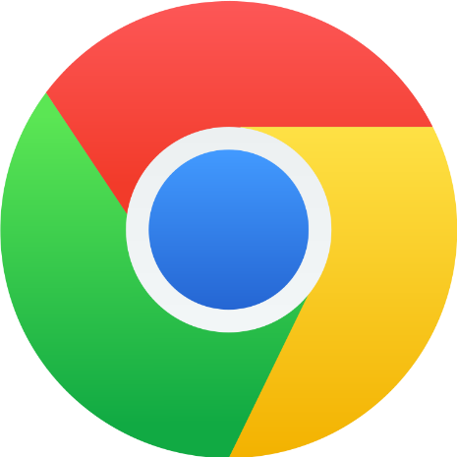

Figure 16 : Chrome Logo

Google Chrome is a free web browser used for accessing the internet and running web applications. It was developed by Google and was released on 2008 (Hoscg, 2025).

Google Chrome supports multiple tabs and bookmarks allowing us in multitasking. It is available for Microsoft Windows, macOS, and other operating systems as well. Google Chrome is a default browser for Google devices including Android phones and Chrome laptops. It also syncs our data such as search and browsing history and passwords, even across other devices while signing into our accounts. It also stands out for efficiency, featuring optimized computer memory usage. Chrome is a popular choice for both personal and professional uses as it is reliable and offers wide range of compatibility with the websites. Chrome's range of extra features, however, goes well beyond the basics. We used Google Chrome for testing and running our codes and also by taking references on the completion our project (Lifewire, 2022).

# 3. Wireframe

## 3.1 Home page

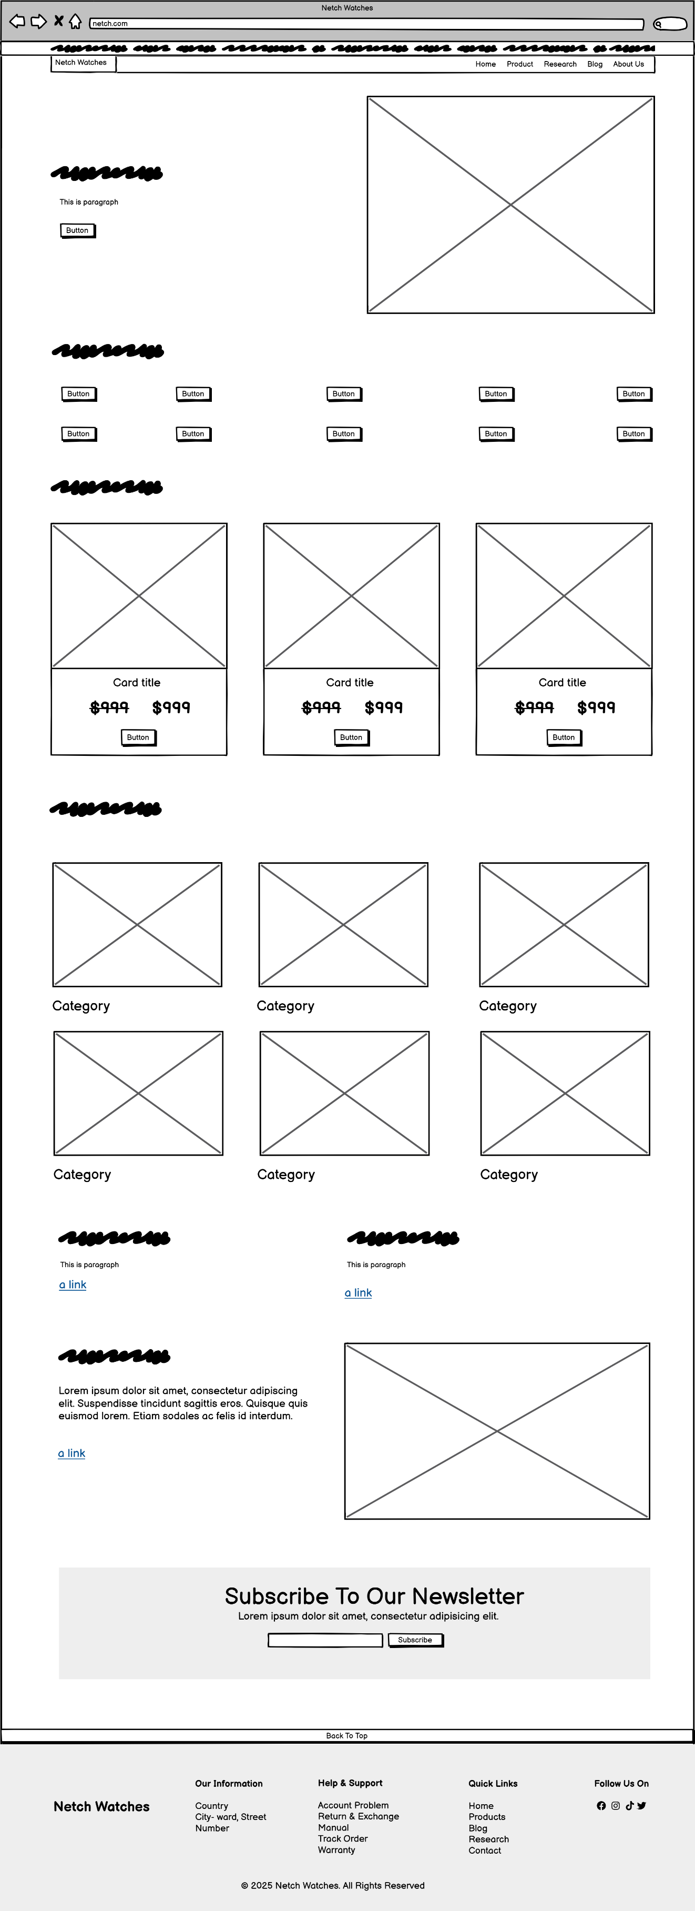

Figure 17 : Wireframe of Home page of our website

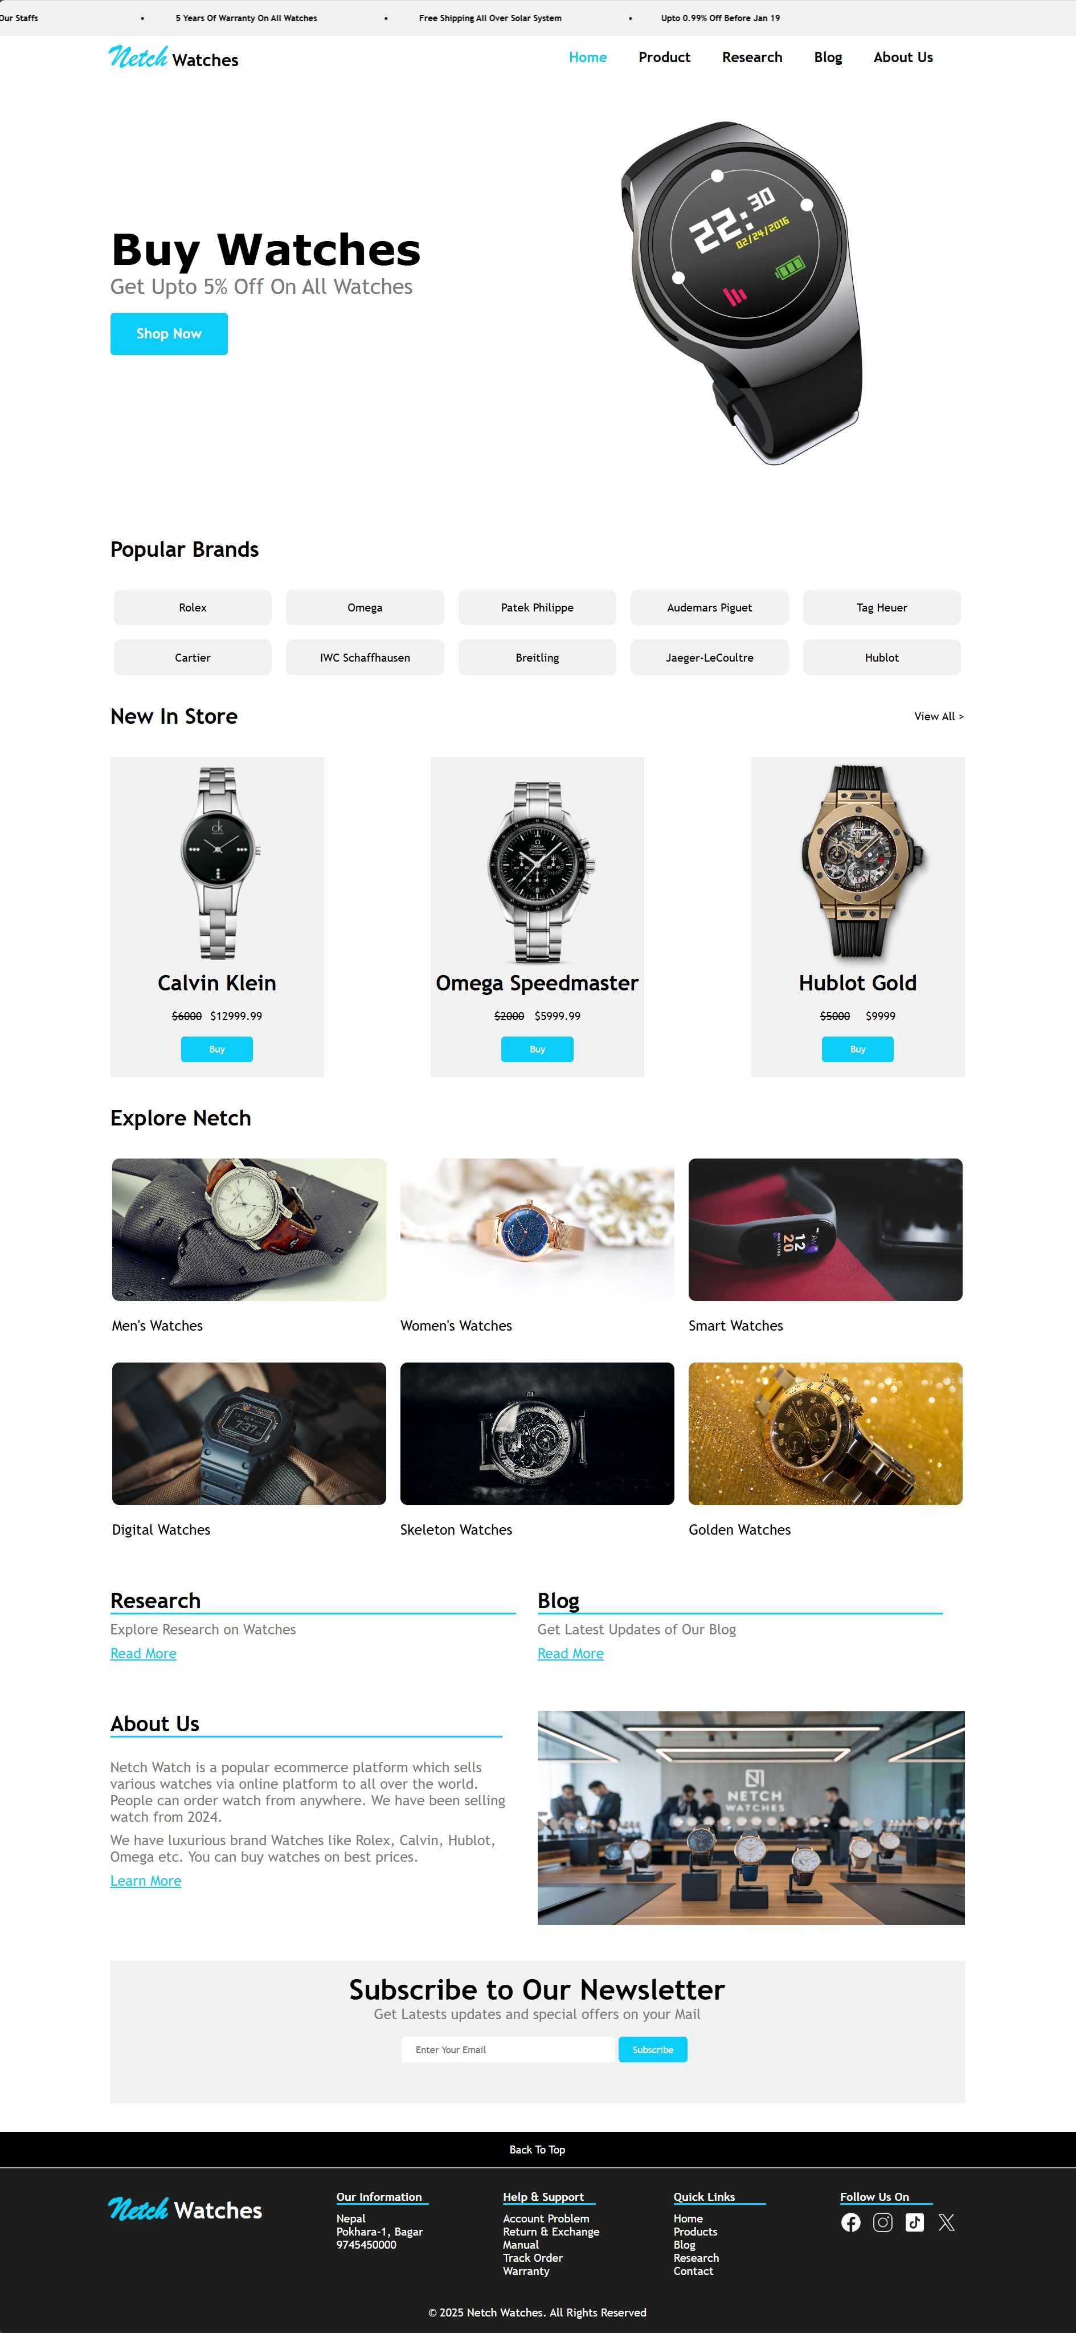

Figure 18 : Home page of our website

This page contains header and footer where header includes marquee and navigation bar where we can travel from home to product to research to blog and so on. The footer section has the necessary contact information of Netch Address. The body section contains popular brands, products, access of research, blog and about us. The header and footer section are included in every other page through external CSS and it also has newsletter.

## 3.2 Product

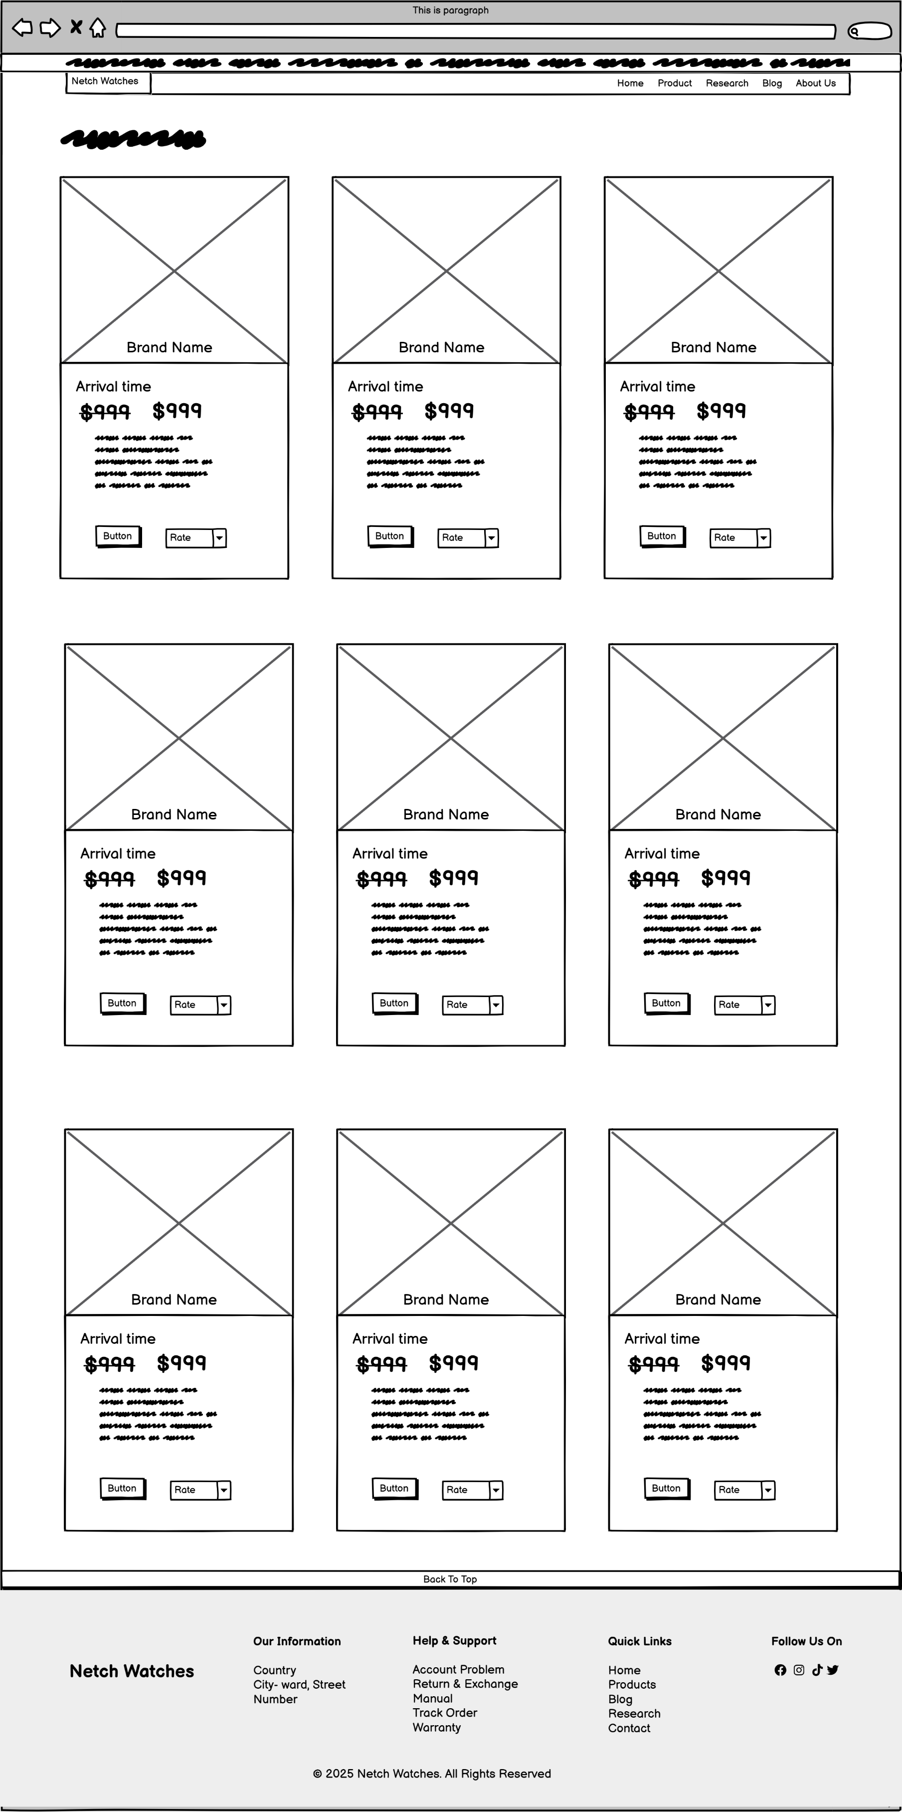

Figure 19 : Wireframe of Product page of our website

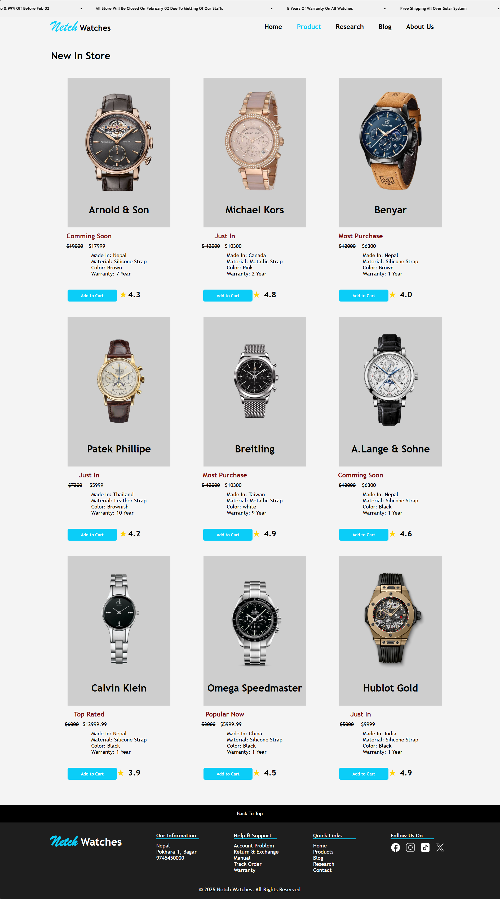

Figure 20 : Product page of our website

The product page contains all the products of watch that are in sale in our inventory. It has products which has just come in, most purchase watch and coming soon which has certain discount price. The product page has ratings star that determines whether people like the products or dislike the products. The product page has the option to buy the product within the discounted price. The product page describes where it is made how it is made and the warranty date of that product. This page has same header and footer as other pages.

## 3.3 Research

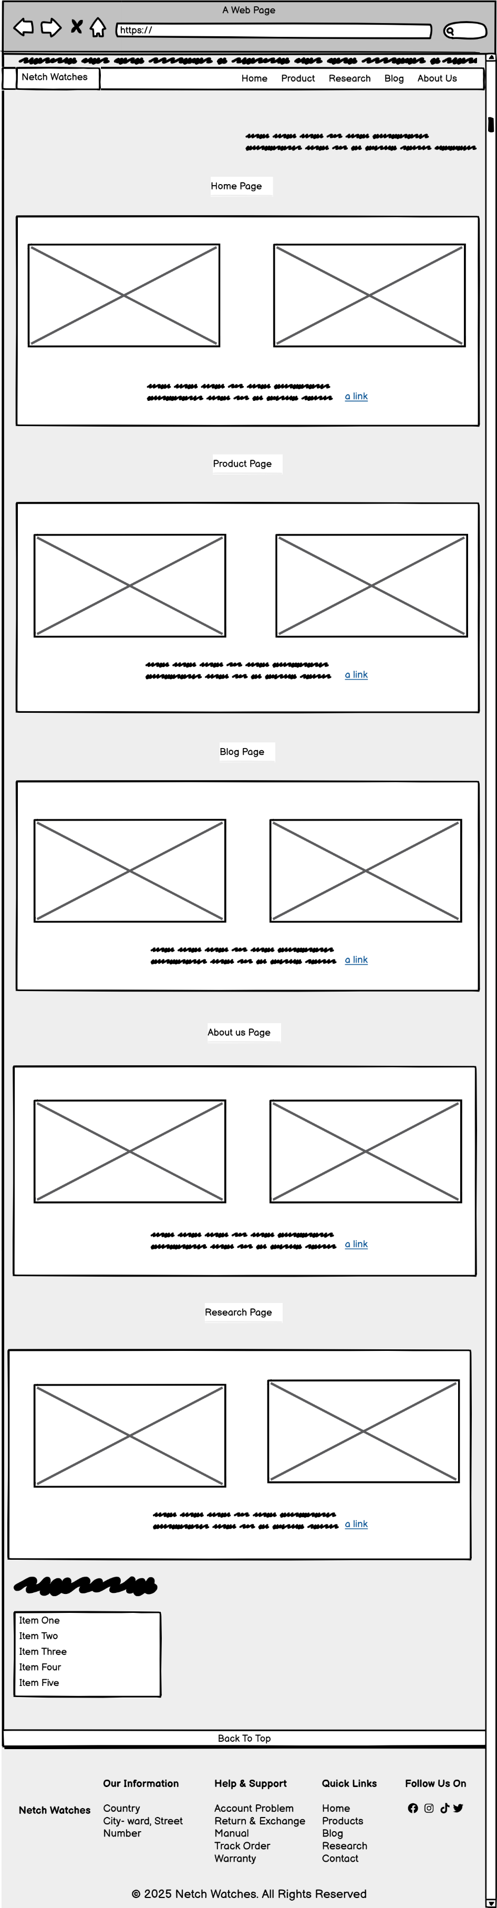

Figure 21 : Wireframe of Research page of our website

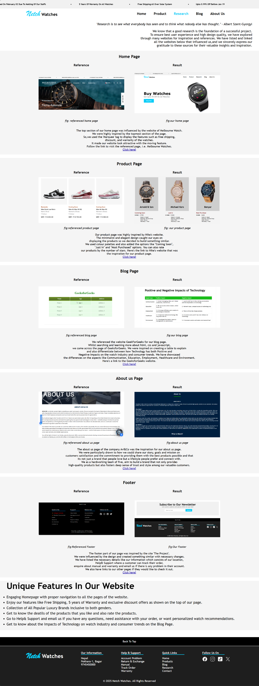

Figure 22 : Research page of our website

Our Research page contains the details that inspired us to make the website and how we create the website with these websites and sources inspirations. This page has 5 references which has the website there they have taken inspiration and which part they has inspired and make reference to our website.

## 3.4 Blog

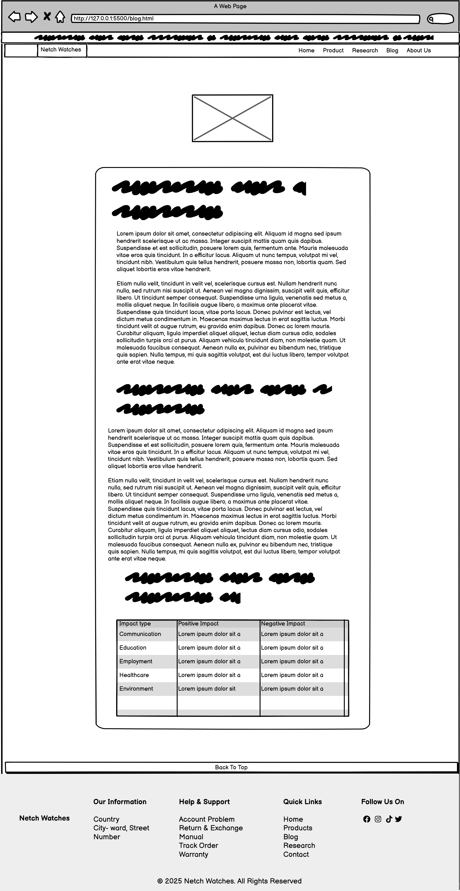

Figure 23 : Wireframe of Blog page of our website

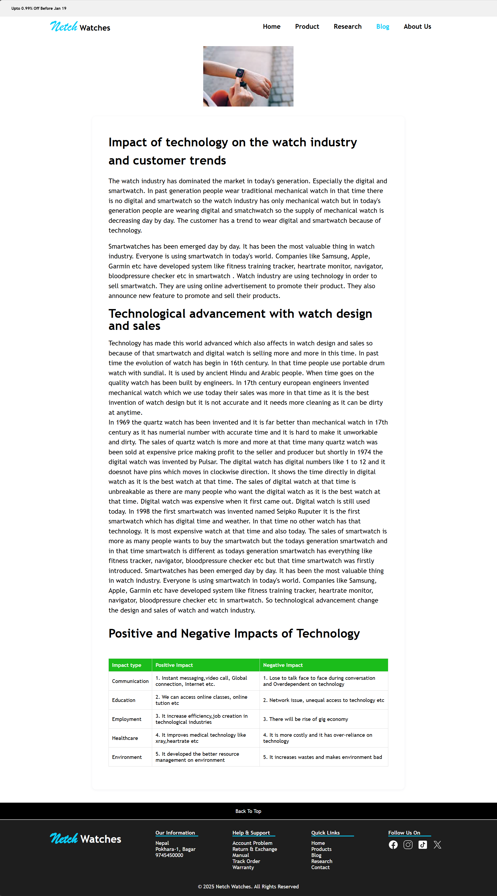

Figure 24 : Blog page of our website

Our blog page covers about the impact of technology on the watch industry and customer trends and the integrate technological advancements with watch design and sales and also the positive and negative impact of technology. We explained what is the impact of technology on the watch industry and how it affects costumer trends? The blog page has the table of positive and negative impact of technology with hover effect. Blog page has same header and footer as other pages.

## 3.5 About Us

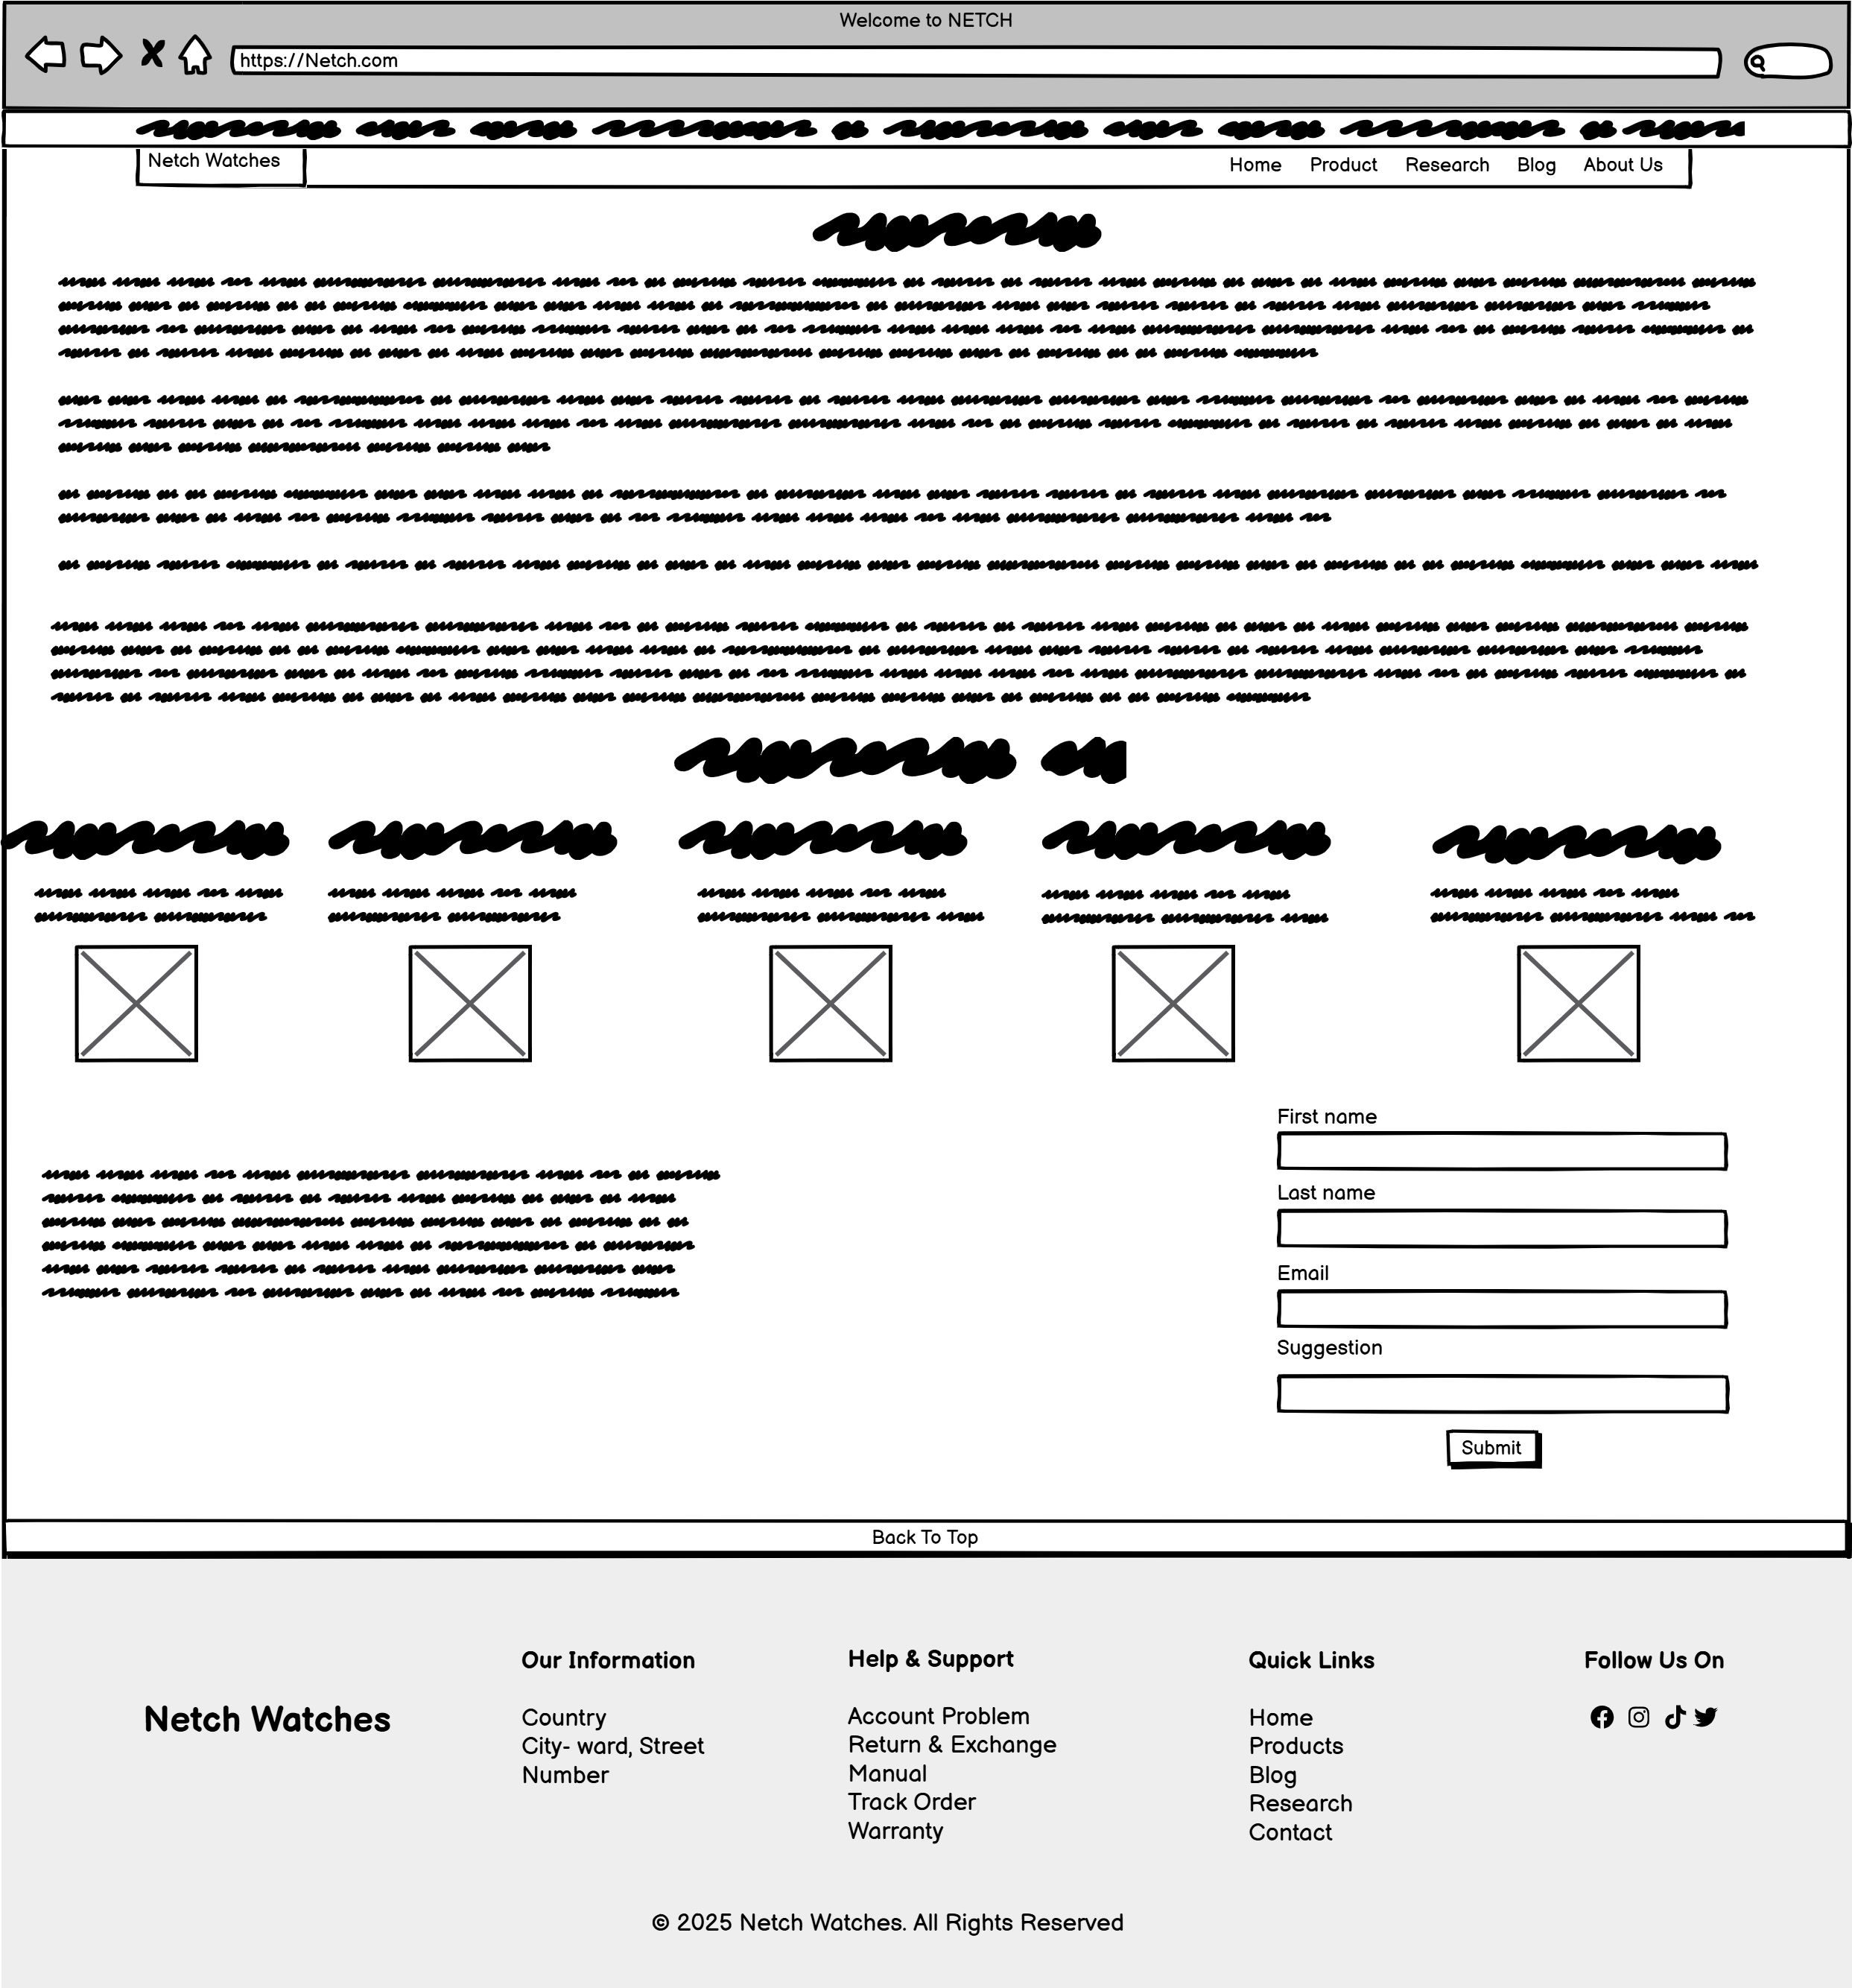

Figure 25 : Wireframe of About Us page of our website

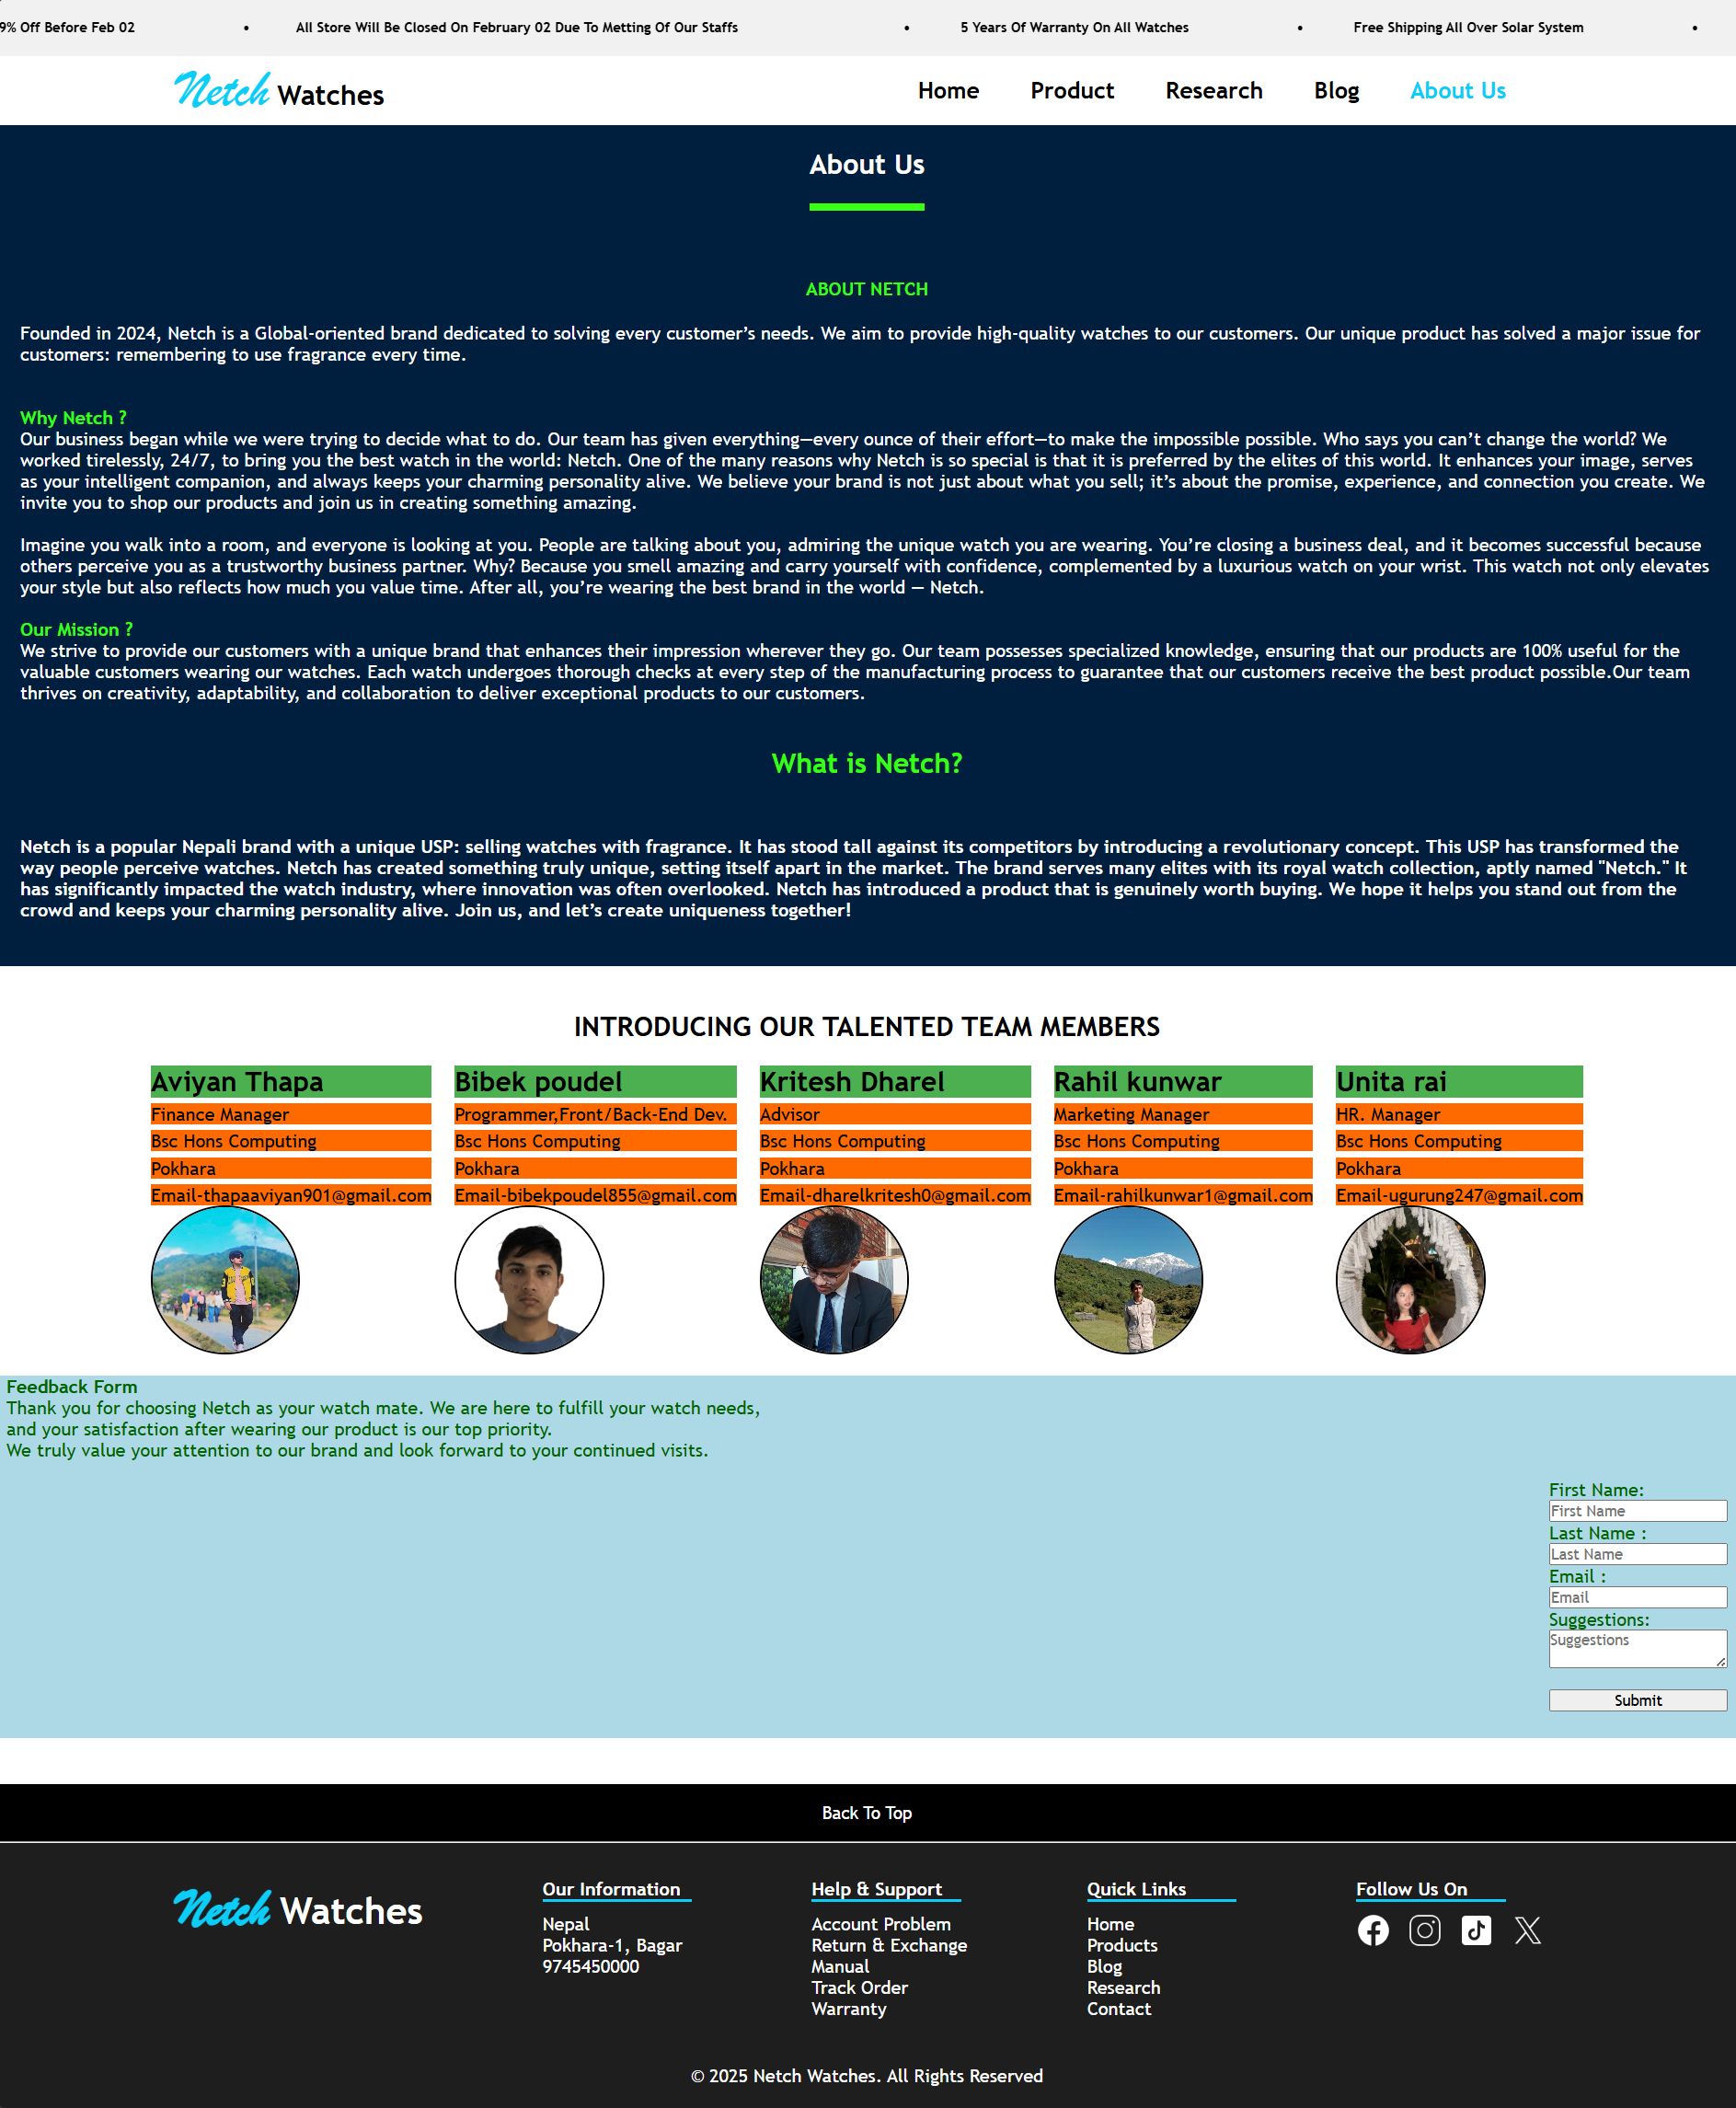

Figure 26 : About Us page of our website

This page contains the name, address, qualification of our development team who develop this website and also has the introduction of our watch brand called Netch and all required description of it. This page also has the feedback form where the customers can feedback us using their First name, Last name, Email and suggestion whether the product is good or not. It has same header and footer as other pages.

# 4. Testing

Testing is a step-by-step process to checking whether the app that we build works properly or works as expected or not. In big companies there is separate team which do several tests. It helps to find or solve different bugs before system or website deployment. If test found fail then it will be resent to developing team to solve.

## 4.1 Objective

* To check whether the web-app works as expected or not.
* To check website is user-friendly or not (smooth, optimized).
* To check it is compatible with all browser & all devices (width/height).
* To find if the app has bug or not.
* To check if the form, navigation bar, & works perfectly or not.

“According to GeeksforGeeks, there are many types of testing & some of are:.”

## 4.2 Types of Testing

**a) Functional Testing**

In this testing we check that features in website works correctly or not. Example, Check nav bar buttons redirect to correct page or not, button works perfectly or not, form is functional or not etc (Geeksforgeeks, 2024).

**b) Performance Testing**

In this testing, we check that website works smoothly without any lag. Example, Check website load faster or not (Geeksforgeeks, 2024).

**c) Compatibility Testing**

In this testing we check that website works on all devices, browsers etc (Geeksforgeeks, 2024).

**d) Usability Testing**

In this testing we check website is user-friendly or not or user can use easily without needing other help (Geeksforgeeks, 2024).

But, we are testing some specific type of testing.

## 4.3 Tools Used in Testing

Browser: Microsoft Edge, Brave, Google Chrome, etc.

Device**:** Laptop (Windows 11 Pro).

Other tools**:** Live Server (VS Code Extension), Inspect Window or Console Window etc.

## 4**.4 Testing Scope/What we are testing**

* Compatibility testing on popular browsers.
* Navigation across all pages via nav bar.
* Form validation in About Page
* News-letter validation in home page
* Hover effect testing
* Button or link testing

## 4.5 Functional Testing

### Test 1

|  |  |
| --- | --- |
| **Test Id** | T01 |
| **Objective** | To check newsletter input filed display message in green color if correct email entered & if not show error message in red color. |
| **Action** | 1. Enter Valid Email [netch@gmail.com](mailto:netch@gmail.com) 2. Enter Invalid Email 13242gmail.com |
| **Expected Result** | Get successfully message in green & error message in red colour. |
| **Actual Output** | Both success message & error message comes in same color (gray). |
| **Browser** | Edge |
| **Test Status** | Fail |
| **Comment** | Due to code missing (bug in JS) both message comes in same color. |

Table 1 : News Letter Testing Report

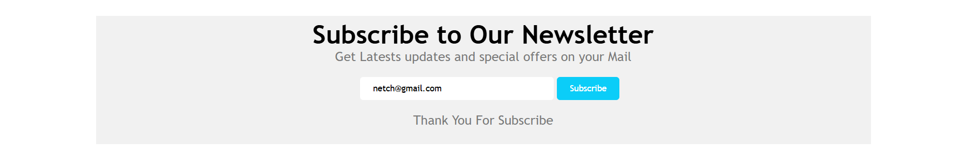

Figure 27 : Entering Correct Mail

In the above image, we see that we entered correct email but success message comes in grey colour, but it wasn’t expected.

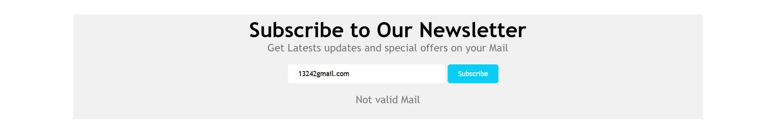

Figure 28 : Entering In Correct Mail

In the above image, we see that we entered incorrect email but shows error message in grey colour instead of red colour.

**Bug Fixing**

The colour was grey in all message because missing colour changing statement of CSS in JS was missing.

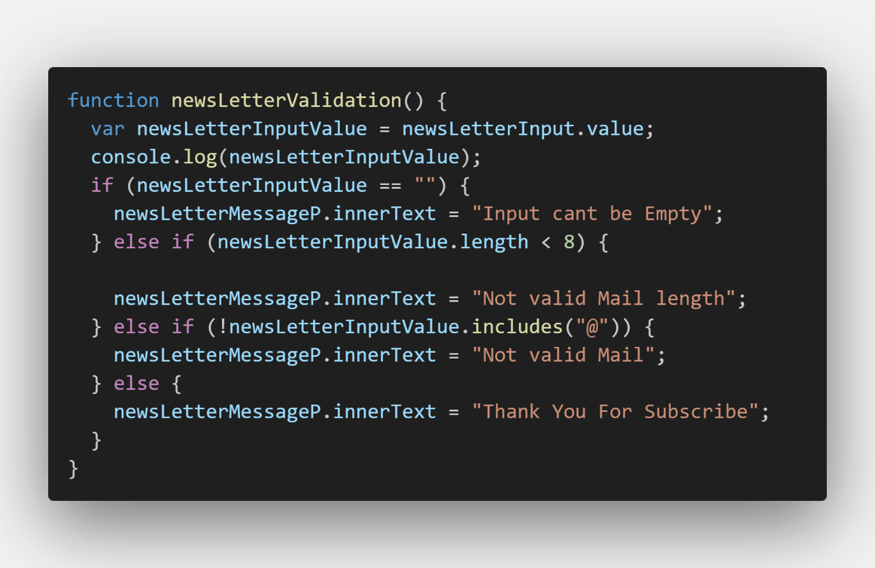

Figure 29 : Missing Colour Changing Statement

We have updated code in JS to change colour dynamically of CSS based on if else condition.

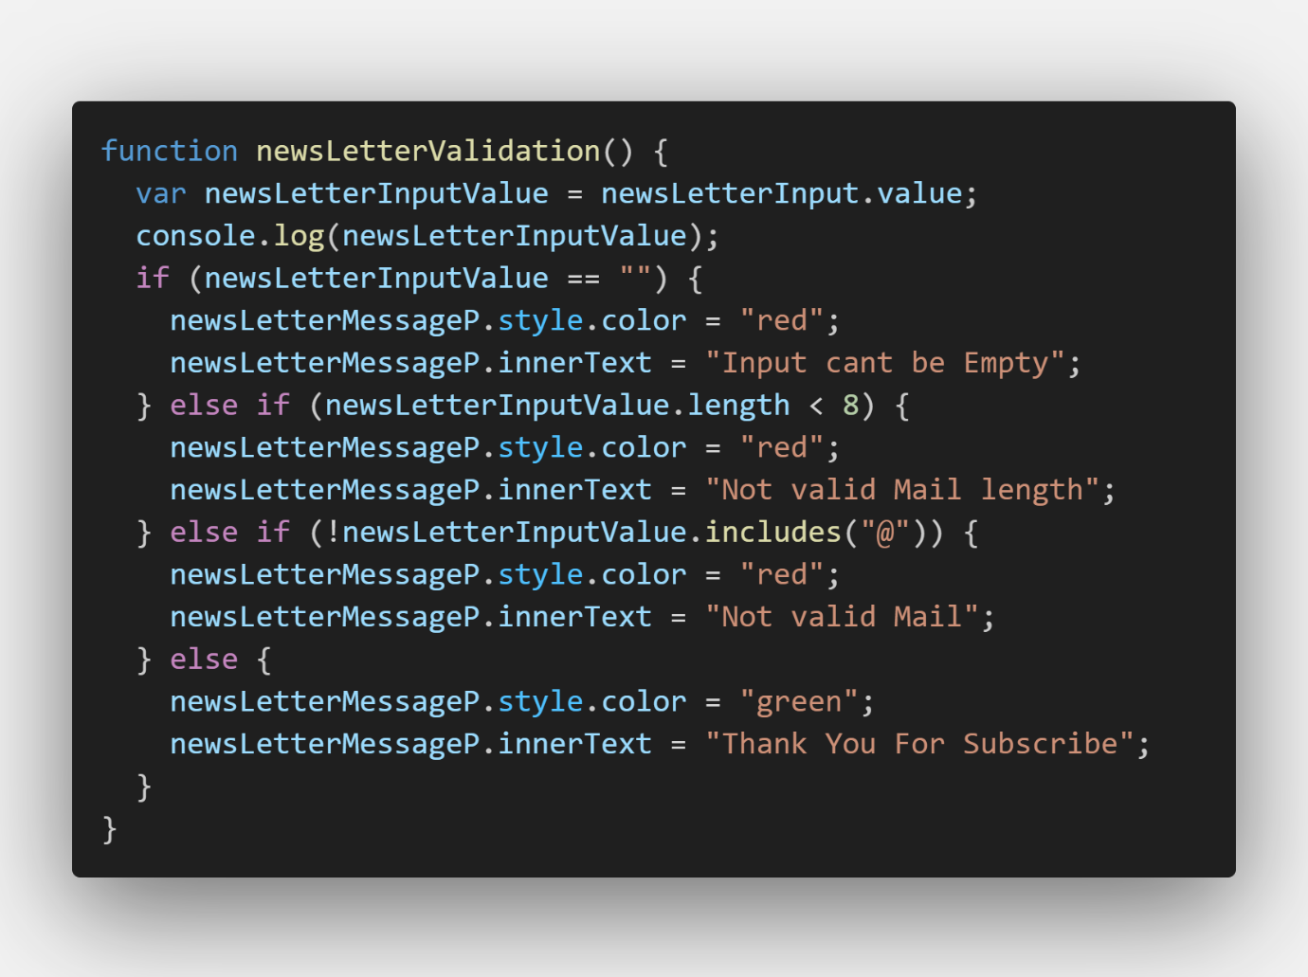

Figure 30 : Added Colour Changing Statement

**Re-Testing**

|  |  |
| --- | --- |
| **Test Id** | T02 |
| **Objective** | To check newsletter input filed display message in green color if correct email entered & if not show error message in red color. |
| **Action** | 1. Enter Valid Email [netch@gmail.com](mailto:netch@gmail.com) 2. Enter Invalid Email 13242gmail.com |
| **Expected Result** | Get successfully message in green & error message in red colour. |
| **Actual Output** | Both success message & error message comes in green & red color respectively as expected. |
| **Browser** | Edge |
| **Test Status** | Pass |
| **Comment** | Before, changing color code was missing that bug comes but now we have fixed it. |

Table 2 : Newsletter After Bug Fix Report

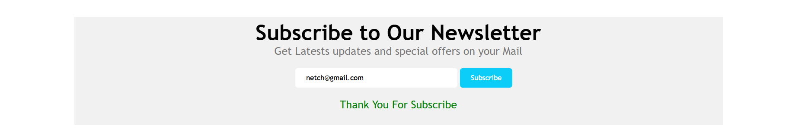

Figure 31 : Newsletter Success Message Shows In Green Colour

In the above image shows, Success message in green colour which was expected.



Figure 32 : Newsletter Error Message Shows in Red Colour

In the above image shows, Error message in red colour which was expected.

### Test 2

|  |  |
| --- | --- |
| **Test Id** | T03 |
| **Objective** | To check About Us page form, by show thankyou message when all detail filled & error message when at least 1 input is empty. |
| **Action** | 1. Enter all data correctly in all input field and submit. 2. Keep all input field empty and submit. |
| **Expected Result** | Thank you message when data is filled correct without empty& error message. |
| **Actual Output** | Thank You message comes when input is correct without empty input field & error message when input field is empty input field. |
| **Browser** | Edge |
| **Test Status** | Pass |
| **Comment** | All result comes as expected so no need to change code. |

Table 3 : Form Validation Testing Report

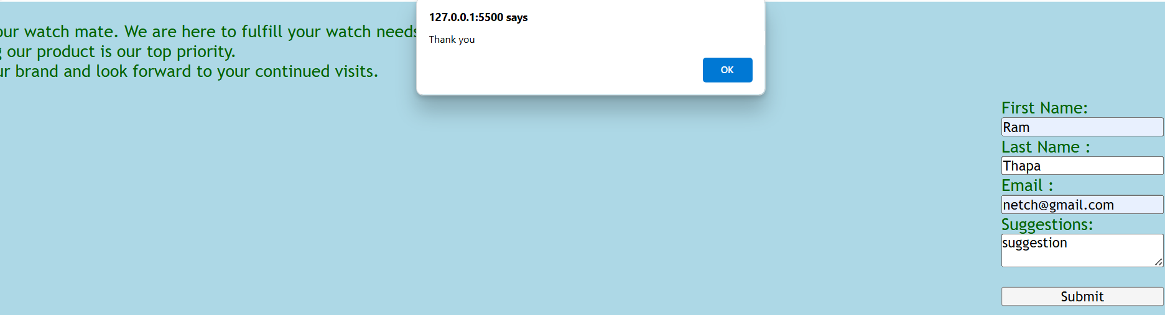

Figure 33 : Showing Thank You when input is not Empty

In the above image, shows thank you message via alert method of JS when input field is not empty, which is expected.

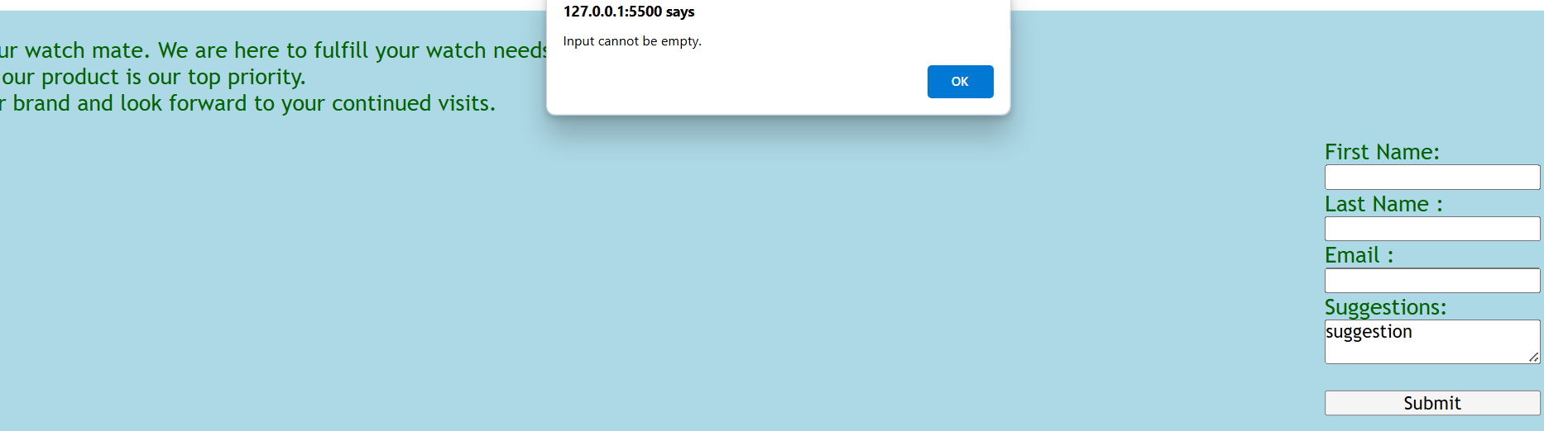

Figure 34 : Shows error when input is empty

In the above image, shows Error message via alert method of JS when input field is empty, which is expected.

### Test 3

|  |  |
| --- | --- |
| **Test Id** | T04 |
| **Objective** | To check navigation bar works perfectly or not, which ensures that each button or anchor tag redirect to correct page. |
| **Action** | 1. Go to each page via nav bar. 2. Check each a tag redirect to correct page or not. |
| **Expected Result** | Each a tag redirect to correct like Product a tag redirect to Product page and other. |
| **Actual Output** | Each a tag redirects to correct page. |
| **Browser** | Edge |
| **Test Status** | Pass |
| **Comment** | All nav bar a tag redirect to correct page which was expected. So, no need to change code. |

Table 4 : Navigation Bar Testing Report

Showing all nav bar redirect to correct page or not is not possible because there are many nav buttons in each page which leads document bad. So, showing some examples of nav bar redirect to correct page.

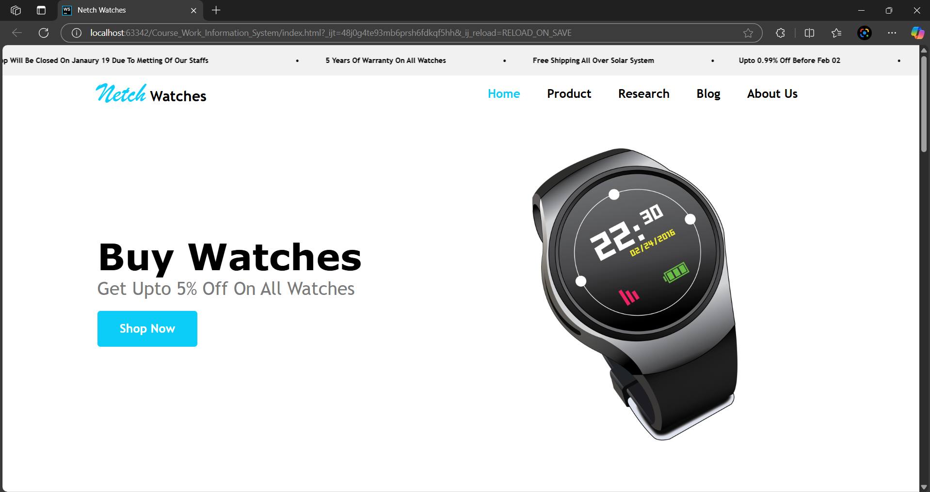

Figure 35 : Home Page

In the above image shows, Home page & testing started from Home to other pages.

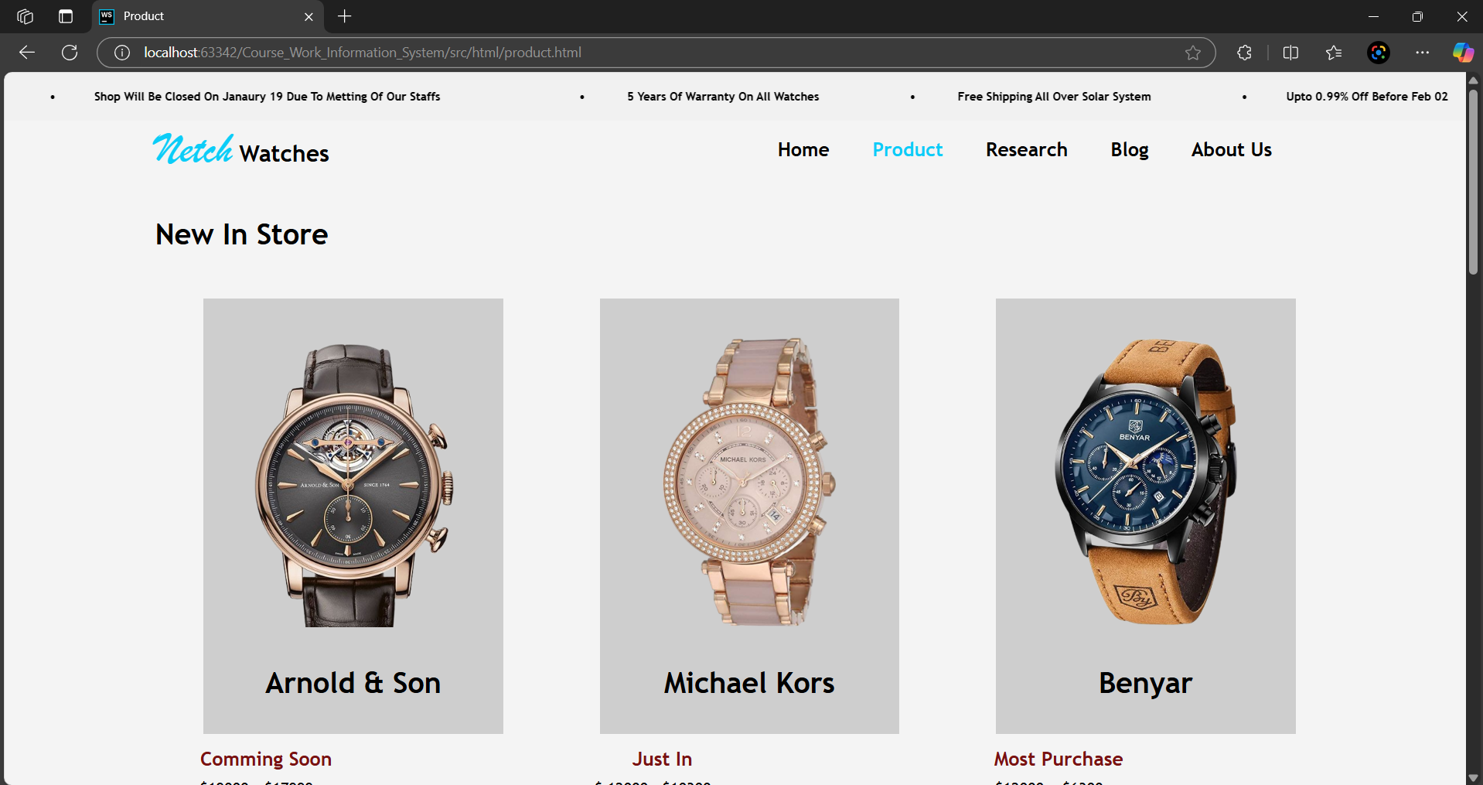

Figure 36 : Product Page

In above image, shows product which was redirected from home page and it was expected.

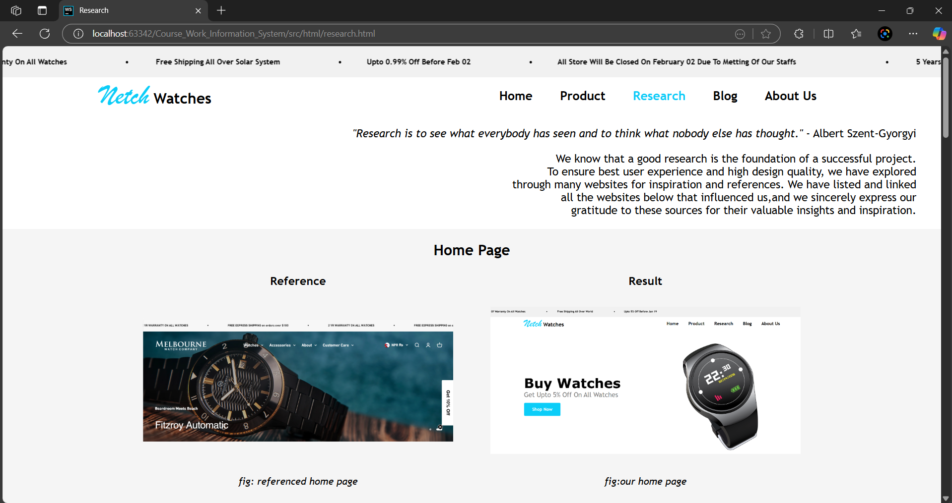

Figure 37: Research Page

In the above image shows research page which was redirected from home page nav bar and it was expected.

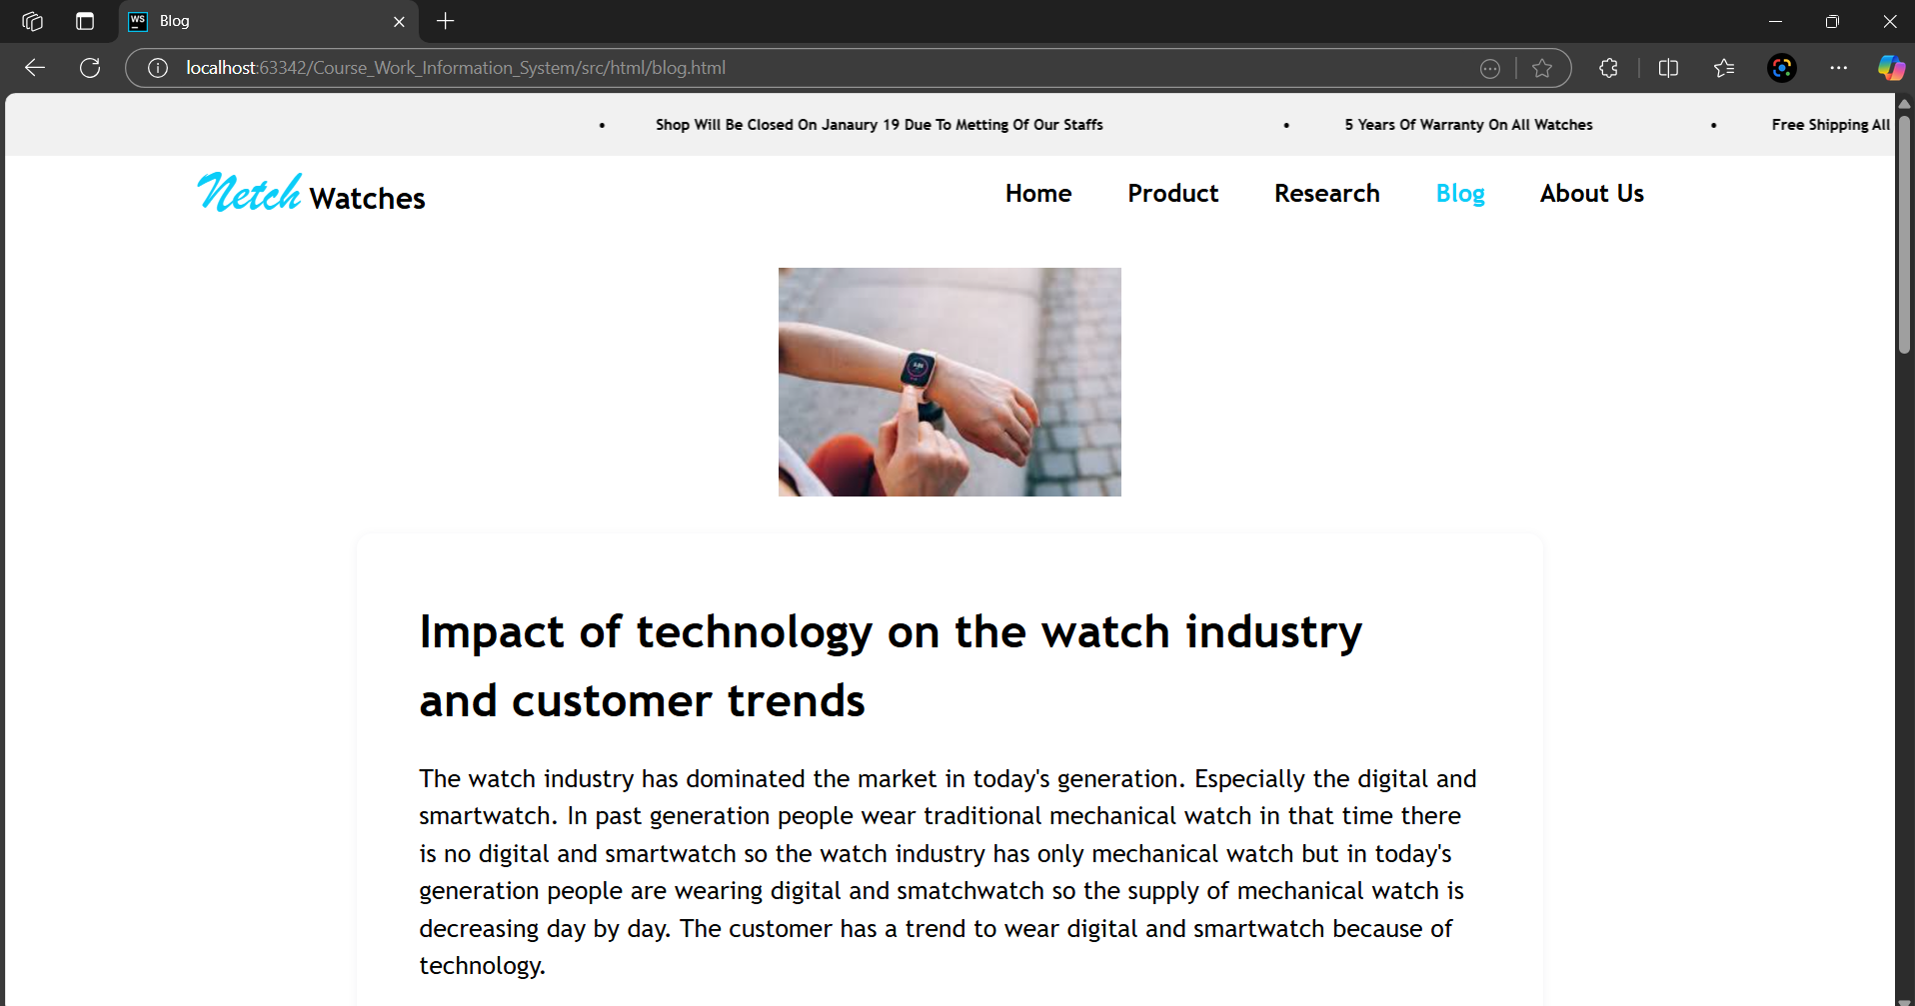

Figure 38 : Blog Page

In the above image, shows blog page which was redirected from home page, which was expected.

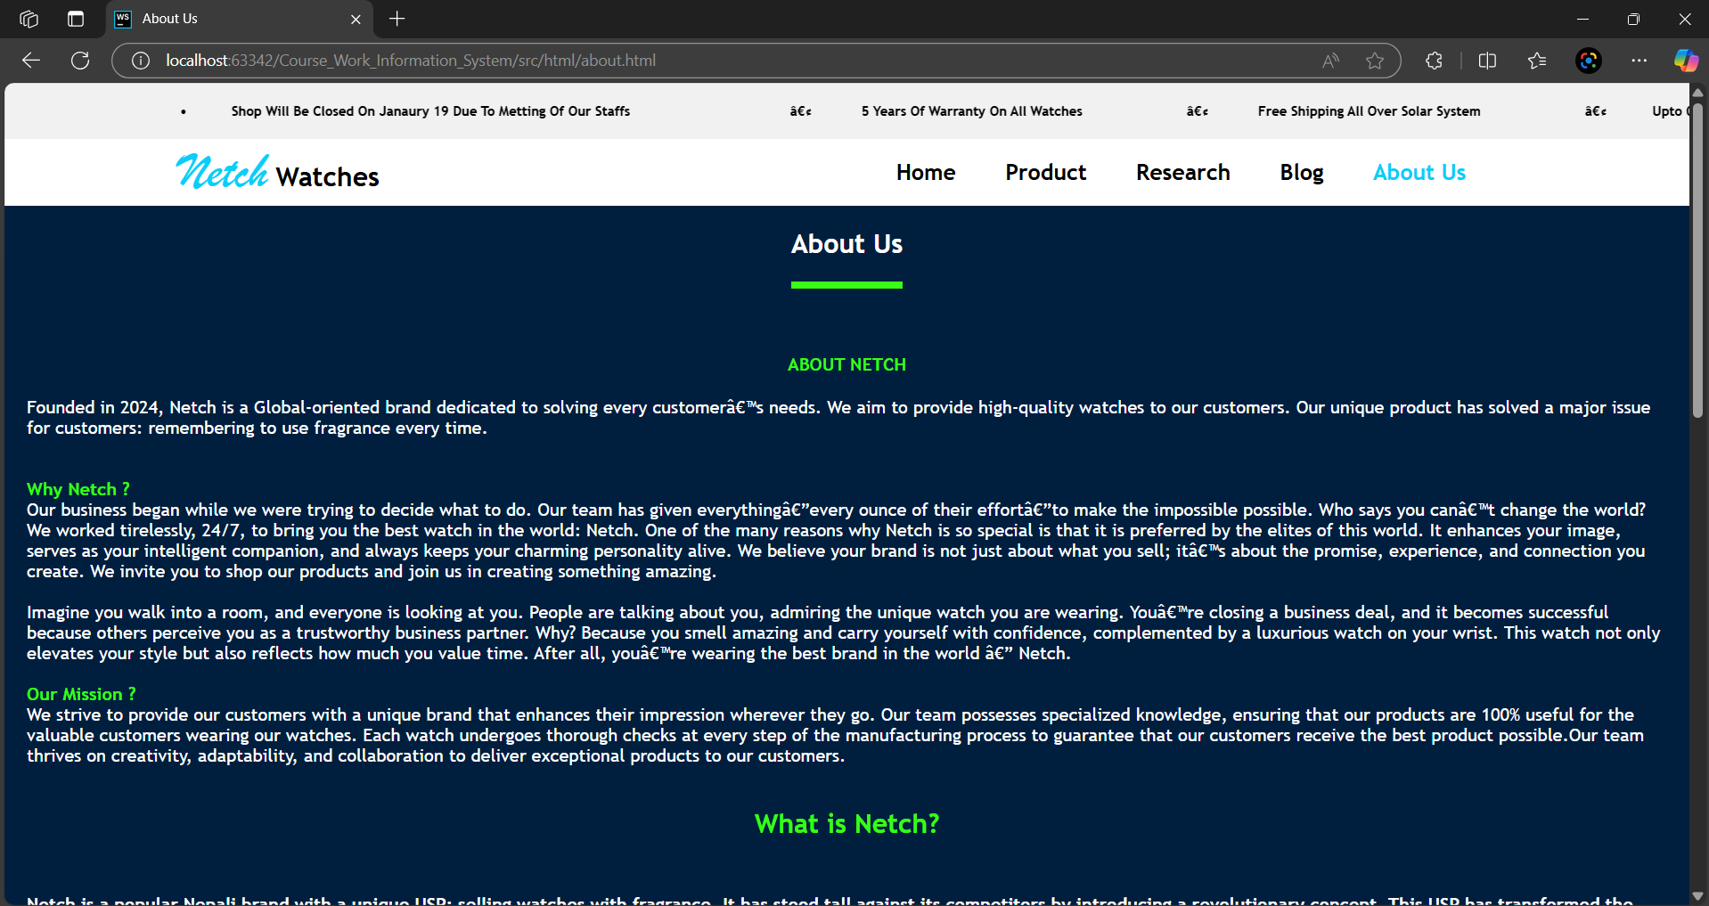

Figure 39 : About Page

In the above image, shows about page which was redirected from home page which was expected.

### Test 4

|  |  |
| --- | --- |
| **Test Id** | T05 |
| **Objective** | To check Back to Top button works perfectly or not, which ensures better user experience. |
| **Action** | 1. Click on Back to Top Button |
| **Expected Result** | Page should go to top smoothly. |
| **Actual Output** | Page goes to top smoothly. |
| **Browser** | Edge |
| **Test Status** | Pass |
| **Comment** | Actual output comes as expected. So, no need to change code. |

Table 5 : Back to top button Testing Report

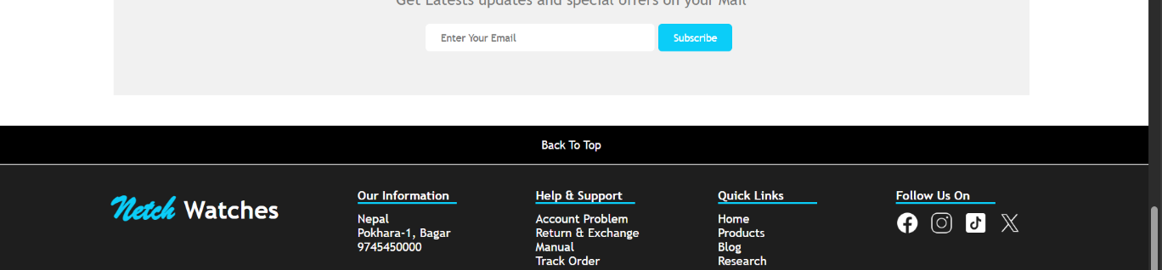

Figure 40 : Before click back to top button

In the above image, we see footer section in home page and we are clicking back to top button.



Figure 41 : Result after click back to top

In the above image shows, home page after clicking back to top button of footer.

### Test 5

|  |  |
| --- | --- |
| **Test Id** | T06 |
| **Objective** | To check hover effect works or not in product page |
| **Action** | 1. Hover Buy button on Product Page |
| **Expected Result** | After hover button, background color of button should be changed smoothly. |
| **Actual Output** | Background color of button changed. |
| **Browser** | Edge |
| **Test Status** | Pass |
| **Comment** | Actual output comes expected. So, no need to change code. |

Table 6 : Hover Effect Testing Report

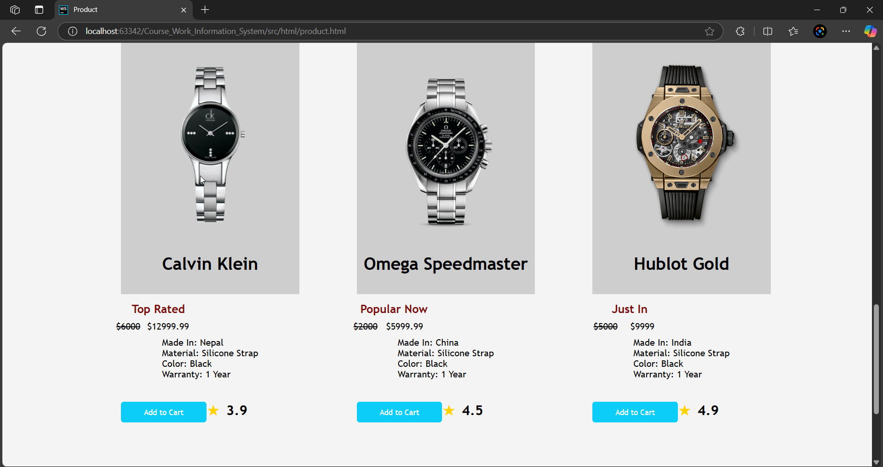

Figure 42 : Before Hover

In the above image shows, product page before hover buy now button.

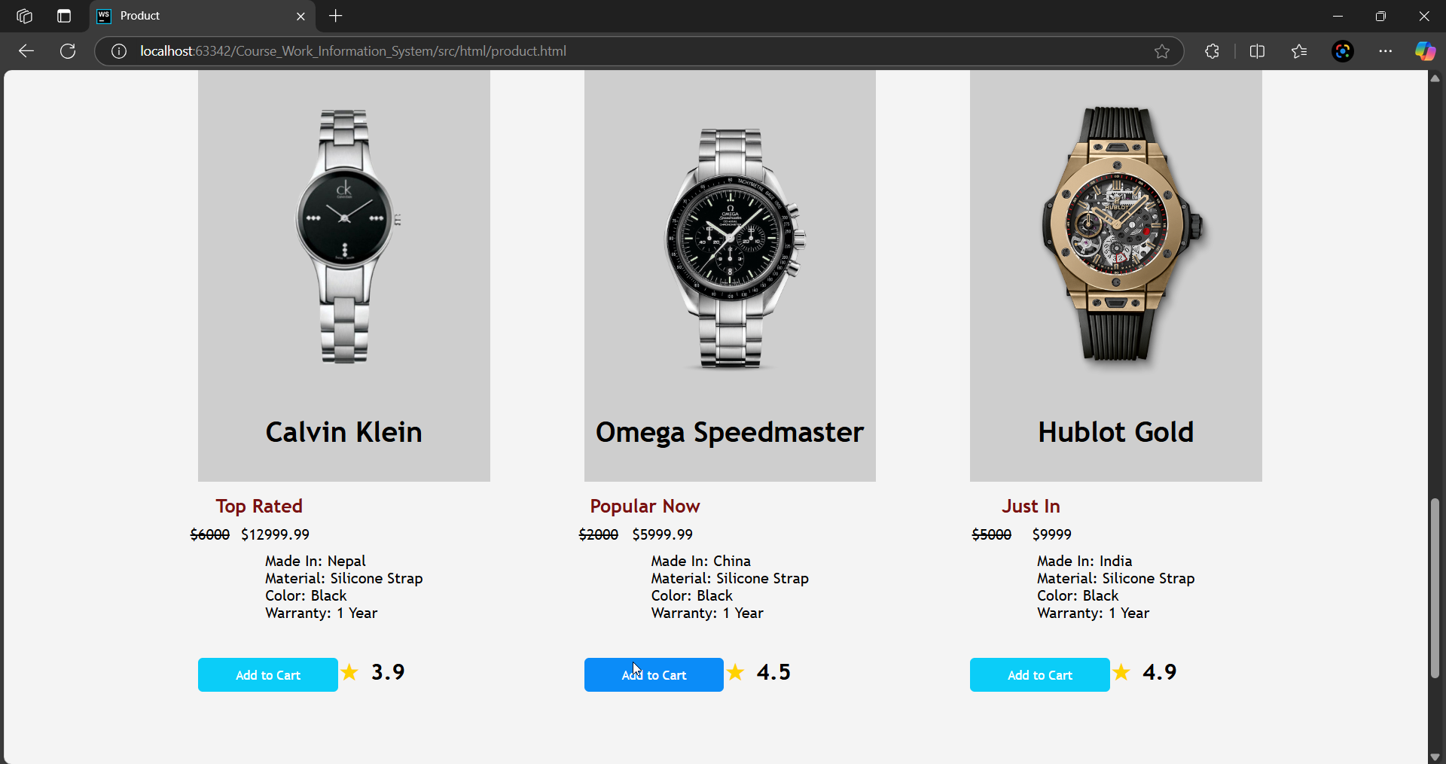

Figure 43 : After Hover

In the above image shows, product page after hover buy button.

## 4.6 Compatibility Testing

In this testing we are checking browser compatibility testing where we check our website functions works properly on common browser or not. We are checking on most common browser. Due to documentation limit we cannot demonstrate all feature because it will be difficult to demonstrate.

### Test 6

|  |  |
| --- | --- |
| **Test Id** | T07 |
| **Objective** | To check website properly works on different browser or not, which ensures better user experience. |
| **Action** | 1. Load website on different browser 2. Check features works properly or not |
| **Expected Result** | All feature should be work properly |
| **Actual Output** | All feature works |
| **Browser** | Edge, Brave, Chrome |
| **Test Status** | Pass |
| **Comment** | As all features works expected so we don’t need to change code for specific browser. |

Table 7 : Browser Compatibility Testing Report

We cannot show all feature works or not. So, we show

only it loads perfectly or not in different browser.

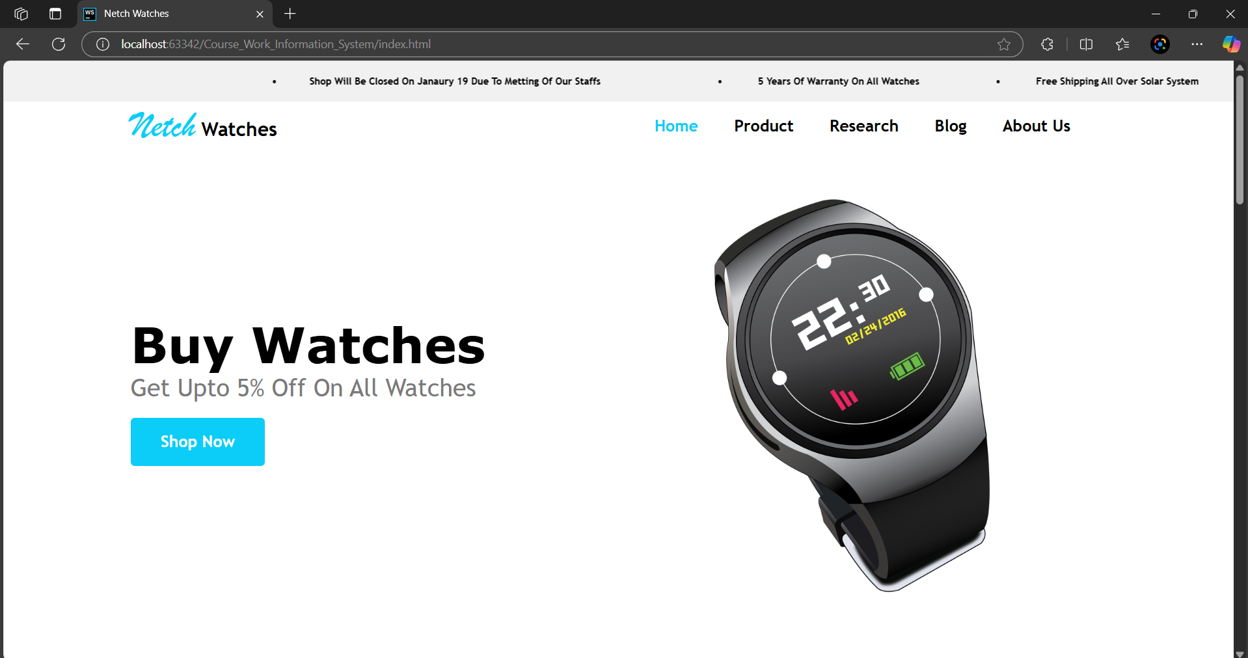

Figure 44 : Compatibility Testing in EDGE Browser

In the above image shows, our website works perfectly on *Edge* browser by Microsoft.

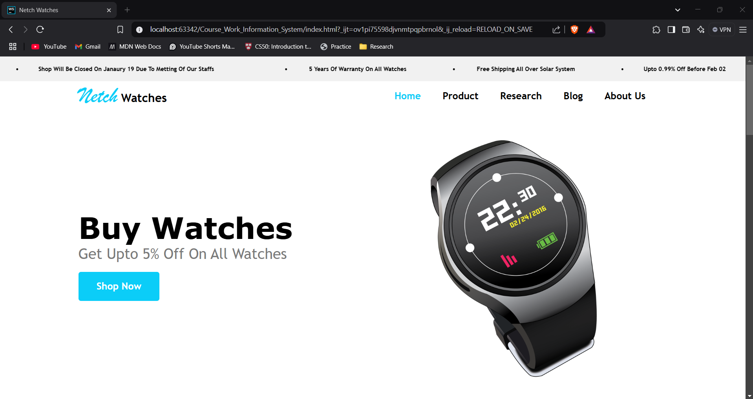

Figure 45 : Compatibility Testing in BRAVE Browser

In the above image shows, our website works perfectly on *Brave* browser.

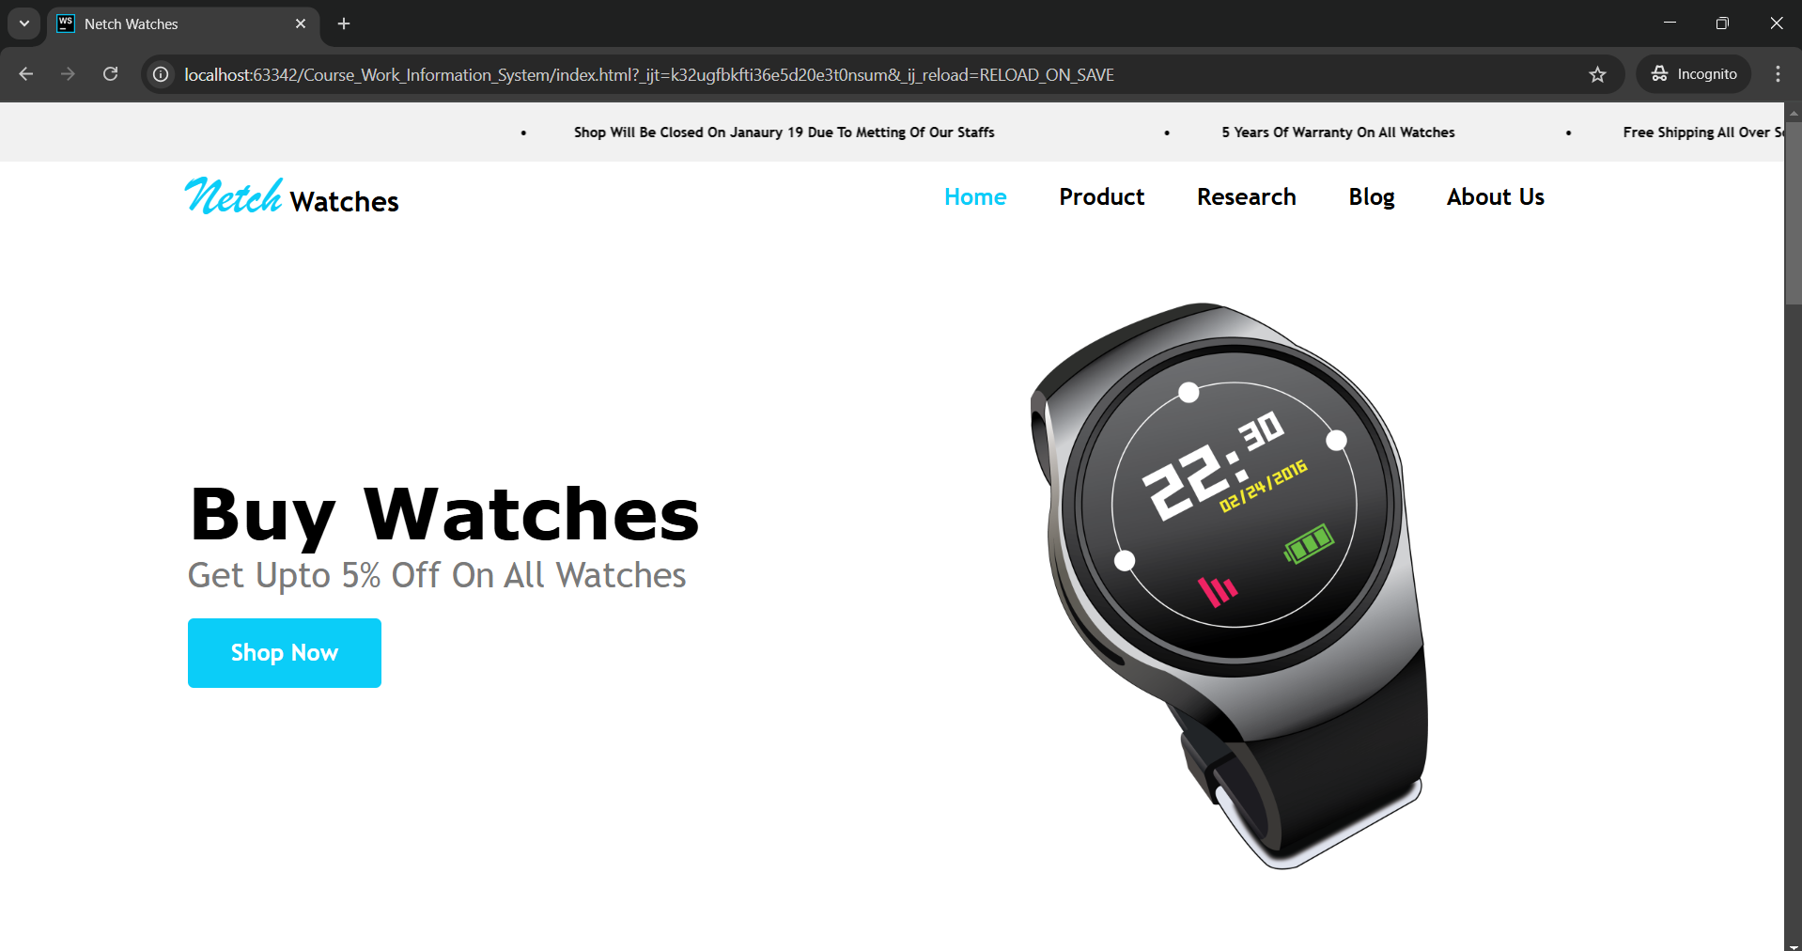

Figure 46 : Compatibility Testing in CHROME Browser

In the above image shows, our website works perfectly on *Chrome* browser by Google.

**Summary of Test Report**

|  |  |  |
| --- | --- | --- |
| **Total Tests** | **Passed Tests** | **Failed Tests** |
| 7 | 6 | 1 |

Table 8 : Summary of Overall Tests Report

# 5. Conclusion

In this report, we describe the process of creating a website design using Html, CSS and JavaScript. We used various tags. As newcomers to this field, the journey was initially challenging and frustrating because we lacked knowledge about many things. At first, we didn't even know how to start the project. However, inspired by the saying, "Where there's a will, there's a way, (George Herbert). We conducted thorough research using various sources, including YouTube and Google. This made the process of making the website engaging and educational, ultimately helping us to complete the project on time.

Throughout this process, we learned many new concepts, faced many challenges, and fixed various issues. Some of these challenges even made us to modify the design we initially thought of doing. One major insight we gained was about the importance of wireframes in website development. Before learning about wireframes, we assumed that websites were created only using HTML, CSS, and JavaScript. However, we discovered that wireframes play a major role in planning and structuring a website.

We faced several problems while working with HTML, CSS, and JavaScript, such as linking these files correctly, using external css and js files, properly applying HTML tags, alignment issues, form validation, image placement issues and time management also known to be a serious challenge, and meeting deadlines often caused our team to panic. Despite having these challenges, our objective to learn new thing, combined with research, teamwork, guidance, and experimentation, helped us to overcome these challenges. We successfully created a fully functional and beautiful website that meets all specified requirements. This project reflects the hard work, dedication, and commitment we invested in achieving our goal. The limited time to learn and execute the project was really and hard task it could be better by first adding learning part then after an execution of that learning part.

# 6 References

CodecademyTeam, 2025. [Online]   
Available at: https://www.codecademy.com/article/html-inline-styles

Geeks for geeks, 2024. [Online]   
Available at: https://www.geeksforgeeks.org/what-is-css/

Geeks for Geeks, 2024. [Online]   
Available at: https://www.geeksforgeeks.org/what-is-github-and-how-to-use-it/

Geeksforgeeks, 2024. [Online]   
Available at: https://www.geeksforgeeks.org/internal-css/

Geeksforgeeks, 2024. [Online]   
Available at: https://www.geeksforgeeks.org/types-software-testing/

Geeksforgeeks, 2024. [Online]   
Available at: https://www.geeksforgeeks.org/what-is-external-javascript/

Hoscg, W. L., 2025. [Online]   
Available at: https://www.britannica.com/technology/Chrome

Jasiulionis, D., 2024. [Online]   
Available at: https://www.hostinger.com/tutorials/what-is-vs-code

Javatpoint, 2025. [Online]   
Available at: https://www.javatpoint.com/external-css

Lifewire, 2022. [Online]   
Available at: https://www.lifewire.com/what-is-google-chrome-4687647

Lutkevich, B., 2020. *Server SIte.* [Online]   
Available at: https://www.theserverside.com/definition/HTML-Hypertext-Markup-Language

Makhani, R., 2024. [Online]   
Available at: https://intellipaat.com/blog/what-is-balsamiq/

Megida, D., 2021. [Online]   
Available at: https://www.freecodecamp.org/news/what-is-javascript-definition-of-js

Rayini, B., 2021. [Online]   
Available at: https://www.geeksforgeeks.org/introduction-to-microsoft-word/

School, W., n.d. [Online]   
Available at: https://www.w3schools.com/tags/

Schultz, K., 2025. *esw.* [Online]   
Available at: https://esw.com/how-ecommerce-has-changed-consumer-behaviour/

Team, C., n.d. [Online]   
Available at: https://www.codecademy.com/article/html-inline-styles

W3School, 2025. [Online]   
Available at: https://www.w3schools.com/tags/

Wright, L., 2019. [Online]   
Available at: https://www.core.co.uk/blog/blog/history-microsoft-word

# 7 Appendix

## 7.1 Home Page HTML/CSS

<!DOCTYPE html>

<html lang="en">

<head>

  <meta charset="UTF-8" />

  <meta name="viewport" content="width=device-width, initial-scale=1.0" />

  <meta name="description"

    content="Buy Your Next Luxury Watch from Netch Watches. You Can Get Discounts On Any Watches. We Will Deliver Across World." />

  <meta name="keywords"

    content="Watch Ecommerce, Rolex, Watch, Netch Watches, Buy Watch, Smart Watch, Skeleton Watch, Netch" />

  <meta name="author" content="Aviyan Thapa,Bibek Poudel,Kritesh Dharel, Rahil Kunwar, Unita Rai">

  <title>Netch Watches</title>

  <!-- linking css file for common code  -->

  <link rel="stylesheet" href="css/style.css" />

  <!-- internal css  -->

  <style>

    /* Hero Section */

    .hero {

      display: flex;

      justify-content: space-between;

      align-items: center;

    }

    /* left section  */

    .hero-left-content {

      height: 600px;

      width: 628px;

      padding: 200px 0px;

      /* background-color: red; */

    }

    .hero .hero-left-content h1 {

      font-size: 60px;

      font-family: sans-serif;

      font-family: "Lucida Grande", "Verdana", "Segoe UI", "Arial", sans-serif;

      font-weight: 900;

    }

    .hero .hero-left-content button {

      /* display: inline-block; */

      padding: 18px 37px;

      margin-top: 20px;

      background-color: #0bcdf8;

      color: white;

      font-size: 20px;

      font-weight: 600;

      border: none;

      border-radius: 5px;

      transition: all 0.4s ease;

    }

    .hero .hero-left-content button:hover {

      background-color: #0b8cf8;

      font-size: 20.2px;

    }

    /* right section hero  */

    .hero-right-section {

      width: 628px;

      height: 600px;

    }

    /* popular brand section  */

    .brand-list-container {

      display: flex;

      flex-wrap: wrap;

      justify-content: center;

      gap: 20px;

    }

    .all-brand-div {

      display: flex;

      justify-content: center;

      align-items: center;

      height: 50px;

      width: 222px;

      background-color: #f1f1f1;

      border-radius: 10px;

    }

    .all-brand-div a {

      transition: all 0.3s ease;

    }

    .all-brand-div:hover a {

      color: #0bcdf8;

      cursor: pointer;

    }

    /* new in store section  */

    .new-in-store-up-content {

      display: flex;

      align-items: center;

      justify-content: space-between;

    }

    #view-all-anchor {

      transition: 0.3s ease;

    }

    #view-all-anchor:hover {

      color: #0bcdf8;

      font-size: 17px;

    }

    .new-store-card-container {

      display: flex;

      justify-content: space-between;

    }

    .new-store-card {

      display: flex;

      flex-direction: column;

      align-items: center;

      height: 450px;

      width: 300px;

      background-color: #f1f1f1;

    }

    .new-store-card img {

      height: 300px;

    }

    .new-store-card .card-details {

      display: flex;

      flex-direction: column;

      align-items: center;

    }

    .new-in-store .card-details h6 {

      text-align: center;

      font-size: 30px;

    }

    .new-store-card .card-details .price {

      display: flex;

      justify-content: space-evenly;

      align-items: center;

      width: 150px;

      margin: 20px 0;

    }

    .new-in-store .card-details button {

      padding: 10px 40px;

      background-color: #0bcdf8;

      color: white;

      border: none;

      border-radius: 5px;

      transition: all 0.3s ease;

    }

    .new-in-store .card-details button:hover {

      background-color: #0b8cf8;

      cursor: pointer;

    }

    /* explore netch section  */

    .explore-netch h1 {

      font-size: 30px;

      font-weight: 700;

      margin: 40px 0;

    }

    .explore-netch-card-cont {

      display: flex;

      gap: 20px;

      flex-wrap: wrap;

      justify-content: center;

    }

    .explore-card img {

      width: 385px;

      height: 200px;

      border-radius: 10px;

      object-fit: cover;

    }

    .explore-card h4 {

      font-size: 20px;

      font-weight: 500;

      margin: 20px 0;

    }

    .explore-card a {

      transition: all 0.3s ease;

    }

    .explore-card a:hover {

      color: #0bcdf8;

      cursor: pointer;

    }

    /* research blog section  */

    .research-blog-container {

      justify-content: space-between;

      margin-top: 50px;

      margin-bottom: 70px;

    }

    .research-blog-container h1 {

      font-size: 30px;

      border-bottom: 3px solid #0bcdf8;

      width: 95%;

    }

    .research-blog-container p {

      font-size: 20px;

      color: #7a7a7a;

      margin: 10px 0;

    }

    .research-blog-container a {

      font-size: 20px;

      color: #0bcdf8;

      text-decoration: underline;

    }

    /* about us section  */

    .about-us {

      display: flex;

      margin-top: 50px;

      margin-bottom: 50px;

    }

    .home-about-left-content {

      height: 300px;

      width: 50%;

      padding-right: 20px;

    }

    .home-about-left-content h1 {

      font-size: 30px;

      border-bottom: 3px solid #0bcdf8;

      width: 95%;

    }

    .home-about-texts {

      margin-top: 30px;

      font-weight: 500;

      font-size: 20px;

    }

    .home-about-left-content p {

      color: #7a7a7a;

      margin: 10px 0;

    }

    .home-about-right-content {

      height: 300px;

      width: 50%;

    }

    /* newsletter section  */

    .newsletter {

      display: flex;

      justify-content: center;

      align-items: center;

      height: 200px;

      background-color: #f1f1f1;

    }

    .subscribe-newsletter-content {

      display: flex;

      flex-direction: column;

      align-items: center;

    }

    .subscribe-newsletter-content p {

      font-size: 20px;

      margin: 0 0 20px 0px;

      color: #7a7a7a;

    }

    .subscribe-newsletter-form input {

      padding: 10px 20px;

      width: 300px;

      margin-left: 20px;

      border: none;

      border-radius: 5px;

    }

    .subscribe-newsletter-form button {

      padding: 10px 20px;

      background-color: #0bcdf8;

      color: white;

      border: none;

      border-radius: 5px;

      transition: all 0.7s ease;

    }

    .subscribe-newsletter-form button:hover {

      background-color: #0b8cf8;

    }

  </style>

</head>

<body>

  <header id="header">

    <!--////// top auto scroll marquee //////////-->

    <div class="marquee">

      <marquee class="marquee-top-scroll flex-box" behaviour="alternate" direction="left">

        <span class="marquee-outer-span"><span>&#8226;</span>Shop Will Be Closed On Feb 02 Due To

          Metting Of Our Staffs</span>

        <span class="marquee-outer-span"></span>

        <span class="marquee-outer-span"><span>•</span> 5 Years Of Warranty On All Watches</span>

        <span class="marquee-outer-span"><span>•</span> Free Shipping All Over Solar System</span>

        <span class="marquee-outer-span"><span>•</span>Upto 0.99% Off Before Feb 02</span>

        <span class="marquee-outer-span"><span>•</span>All Store Will Be Closed On February 02 Due To

          Metting Of Our Staffs</span>

        <span class="marquee-outer-span"></span>

        <span class="marquee-outer-span"><span>•</span> 5 Years Of Warranty On All Watches</span>

        <span class="marquee-outer-span"><span>•</span> Free Shipping All Over Solar System</span>

        <span class="marquee-outer-span"><span>•</span>Upto 0.99% Off Before Feb 02</span>

      </marquee>

    </div>

    <!--/////// nav bar  ////////////-->

    <nav class="container">

      <div class="nav-logo">

        <a href="index.html">

          <h1><span>Netch</span> Watches</h1>

        </a>

      </div>

      <div class="nav-link">

        <a href="#" style="color:#0bcdf8;">Home</a>

        <a href="html/product.html">Product</a>

        <a href="html/research.html">Research</a>

        <a href="html/blog.html">Blog</a>

        <a href="html/about.html">About Us</a>

      </div>

    </nav>

  </header>

  <!--/////// main content /////////-->

  <main>

    <!--////// hero section ///////-->

    <section class="hero container" id="hero-container">

      <div class="hero-left-content">

        <h1>Buy Watches</h1>

        <p style="  font-size: 30px;

        font-weight: 500;

        color: #7a7a7a;">Get Upto 5% Off On All Watches</p>

        <button id="shop-now" onclick="shopNowButtonEvent()">Shop Now</button>

      </div>

      <div class="hero-right-content">

        <img style="height: 600px; width: 600px" src="resources/images/Home-Photos/hero-img.png" alt="hero-image" />

      </div>

    </section>

    <!-- ///////popular brand section ///////// -->

    <section class="popular-brands container">

      <h1 style="font-size: 30px;

      font-weight: 700;

      margin: 40px 0;">Popular Brands</h1>

      <div class="brand-list-container">

        <div class="all-brand-div"><a href="https://www.rolex.com" target="_blank">Rolex</a></div>

        <div class="all-brand-div"><a href="https://www.omegawatches.com" target="_blank">Omega</a></div>

        <div class="all-brand-div"><a href="https://www.patek.com" target="_blank">Patek Philippe</a></div>

        <div class="all-brand-div"><a href="https://www.audemarspiguet.com" target="_blank">Audemars Piguet</a></div>

        <div class="all-brand-div"><a href="https://www.tagheuer.com" target="_blank">Tag Heuer</a></div>

        <div class="all-brand-div"><a href="https://www.cartier.com" target="_blank">Cartier</a></div>

        <div class="all-brand-div"><a href="https://www.iwc.com" target="_blank">IWC Schaffhausen</a></div>

        <div class="all-brand-div"><a href="https://www.breitling.com" target="_blank">Breitling</a></div>

        <div class="all-brand-div"><a href="https://www.jaeger-lecoultre.com" target="_blank">Jaeger-LeCoultre</a></div>

        <div class="all-brand-div"><a href="https://www.hublot.com" target="_blank">Hublot</a></div>

      </div>

    </section>

    <!--// new in store section /// -->

    <section class="new-in-store container">

      <div class="new-in-store-up-content">

        <h1 style="font-size: 30px;

        font-weight: 700;

        margin: 40px 0;">New In Store</h1>

        <a href="html/product.html" id="view-all-anchor">View All ></a>

      </div>

      <div class="new-store-card-container">

        <div class="new-store-card">

          <img src="resources/images/Home-Photos/calvin-new-store.png" alt="img" />

          <div class="card-details">

            <h6>Calvin Klein</h6>

            <div class="price">

              <del>$6000</del>

              <p>$12999.99</p>

            </div>

            <button onclick="buyNowButton()">Buy</button>

          </div>

        </div>

        <div class="new-store-card">

          <img src="resources/images/Home-Photos/omega-new-store.png" alt="img" />

          <div class="card-details">

            <h6>Omega Speedmaster</h6>

            <div class="price">

              <del>$2000</del>

              <p>$5999.99</p>

            </div>

            <button onclick="buyNowButton()">Buy</button>

          </div>

        </div>

        <div class="new-store-card">

          <img src="resources/images/Home-Photos/hublot-new-store.png" alt="img" />

          <div class="card-details">

            <h6>Hublot Gold</h6>

            <div class="price">

              <del>$5000</del>

              <p>$9999</p>

            </div>

            <button onclick="buyNowButton()">Buy</button>

          </div>

        </div>

      </div>

    </section>

    <!--///////// explore netch section /////// -->

    <section class="explore-netch container" style="margin-bottom: 20px;">

      <h1>Explore Netch</h1>

      <div class="explore-netch-card-cont">

        <div class="explore-card">

          <img src="resources/images/Home-Photos/explore-men-watch.jpg" alt="img" />

          <h4><a href="html/product.html">Men's Watches</a></h4>

        </div>

        <div class="explore-card">

          <img src="resources/images/Home-Photos/explore-women-watch.jpg.jpg" alt="img" />

          <h4><a href="html/product.html">Women's Watches</a></h4>

        </div>

        <div class="explore-card">

          <img src="resources/images/Home-Photos/explore-smart-watch.jpg" alt="img" />

          <h4><a href="html/product.html">Smart Watches</a></h4>

        </div>

        <div class="explore-card">

          <img src="resources/images/Home-Photos/explore-digital-watch.jpg" alt="img" />

          <h4><a href="html/product.html">Digital Watches</a></h4>

        </div>

        <div class="explore-card">

          <img src="resources/images/Home-Photos/explore-skeleton-watch.jpg" alt="img" />

          <h4><a href="html/product.html">Skeleton Watches</a></h4>

        </div>

        <div class="explore-card">

          <img src="resources/images/Home-Photos/explore-golden-watch.jpg" alt="img" />

          <h4><a href="html/product.html">Golden Watches</a></h4>

        </div>

      </div>

    </section>

    <!-- Research & blog section -->

    <section class="research-blog-container container flex-box">

      <div class="research-blog-left-content" style="width: 50%;">

        <h1>Research</h1>

        <p>Explore Research on Watches</p>

        <a href="html/research.html">Read More</a>

      </div>

      <div class="research-blog-right-content" style="width: 50%;">

        <h1>Blog</h1>

        <p>Get Latest Updates of Our Blog</p>

        <a href="html/blog.html">Read More</a>

      </div>

    </section>

    <!-- about us section  -->

    <section class="container about-us">

      <div class="home-about-left-content">

        <h1>About Us</h1>

        <div class="home-about-texts">

          <p>

            Netch Watch is a popular ecommerce platform which sells various watches via online platform to all over the

            world. People can order watch from anywhere. We have been selling watch from 2024.

          </p>

          <p>We have luxurious brand Watches like Rolex, Calvin, Hublot, Omega etc. You can buy watches on best prices.

          </p>

          <a href="html/about.html" style="   color: #0bcdf8;

      text-decoration: underline;">Learn More</a>

        </div>

      </div>

      <div class="home-about-right-content flex-box">

        <img src="resources/images/Home-Photos/home-about-us.jpeg" alt="about-us" style="height: 100%;

      width: 100%;" />

        <!--image source : ideogram ai  -->

      </div>

    </section>

    <!-- //////////////// newsletter section /////////// -->

    <section class="newsletter container">

      <div class="subscribe-newsletter-content">

        <h2 style="font-size: 40px;

      font-weight: 700;">Subscribe to Our Newsletter</h2>

        <p>Get Latests updates and special offers on your Mail</p>

        <div class="subscribe-newsletter-form">

          <input type="email" placeholder="Enter Your Email" id="newsletter-input" />

          <button id="newsletter-button" onclick="newsLetterValidation()">Subscribe</button>

        </div>

        <p id="message-for-newsletter-validation" style="margin: 20px 0;"></p>

      </div>

    </section>

  </main>

  <!--//////// footer section /////// -->

  <footer>

    <a href="#" class="back-to-top-anchor flex-box">

      <div>Back To Top</div>

    </a>

    <hr />

    <div class="footer-column-container container">

      <div class="footer-logo">

        <a href="index.html" id="footer-logo-a">

          <h1><span>Netch</span> Watches</h1>

        </a>

      </div>

      <div class="footer-column1 footer-column">

        <h4>Our Information</h4>

        <a href="#">

          <p>Nepal</p>

        </a>

        <a href="#">

          <p>Pokhara-1, Bagar</p>

        </a>

        <a href="#">

          <p>9745450000</p>

        </a>

      </div>

      <div class="footer-column2 footer-column">

        <h4>Help & Support</h4>

        <p><a href="https://mail.google.com/mail/?view=cm&fs=1&to=netch@gmail.com" target="_blank">Account Problem</a>

        </p>

        <p><a href="https://mail.google.com/mail/?view=cm&fs=1&to=netch@gmail.com" target="_blank">Return &

            Exchange</a></p>

        <p> <a href="https://mail.google.com/mail/?view=cm&fs=1&to=netch@gmail.com" target="_blank">Manual</a></p>

        <p><a href="https://mail.google.com/mail/?view=cm&fs=1&to=netch@gmail.com" target="_blank">Track Order</a></p>

        <p> <a href="https://mail.google.com/mail/?view=cm&fs=1&to=netch@gmail.com" target="_blank">Warranty</a></p>

      </div>

      <div class="footer-column3 footer-column">

        <h4>Quick Links</h4>

        <p><a href="#">Home</a></p>

        <p><a href="html/product.html">Products</a></p>

        <p><a href="html/blog.html">Blog</a></p>

        <p><a href="html/research.html">Research</a></p>

        <p><a href="html/about.html">Contact</a></p>

      </div>

      <div class="footer-column4 footer-column">

        <h4>Follow Us On</h4>

        <a href="https://facebook.com/netchwatch" target="_blank"><img src="resources/icons/facebook.png"

            alt="facebook" /></a>

        <a href="https://instagram.com/netchwatch" target="_blank"><img src="resources/icons/instagram.png"

            alt="instagram" /></a>

        <a href="https://tiktok.com/netchwatch" target="_blank"><img src="resources/icons/tiktok.png" alt="tiktok" /></a>

        <a href="https://x.com/netchwatch" target="_blank"><img src="resources/icons/x.png" alt="x" /></a>

      </div>

    </div>

    <!-- footer copyright  -->

    <p class="copy-right-para">© 2025 Netch Watches. All Rights Reserved</p>

  </footer>

  <!-- linking js file -->

  <script src="js/script.js"></script>

</body>

</html>

## 7.2 Product Page HTML/CSS

<!DOCTYPE html>

<html lang="en">

<head>

  <meta charset="UTF-8" />

  <meta name="viewport" content="width=device-width, initial-scale=1.0" />

  <title>Product</title>

  <link rel="stylesheet" href="../css/style.css" />

  <meta name="description"

    content="Buy Your Next Luxury Watch from Netch Watches. You Can Get Upto 5% Discount On Any Watches. We Will Deliver Across World." />

  <meta name="keywords"

    content="Watch Ecommerce, Rolex, Watch, Netch Watches, Buy Watch, Smart Watch, Skeleton Watch, Netch" />

  <meta name="author" content="Aviyan Thapa,Bibek Poudel,Kritesh Dharel, Rahil Kunwar, Unita Rai">

  <style>

    body {

      font-family: Arial, sans-serif;

      margin: 0;

      padding: 0;

      background-color: #f4f4f4;

    }

    .new-in-store {

      margin-bottom: 300px;

    }

    .new-in-store h1 {

      font-size: 30px;

      font-weight: 700;

      margin: 40px 0;

    }

    .new-store-card-container {

      display: flex;

    }

    .new-store-card-container-second {

      margin-top: 260px;

      display: flex;

    }

    .new-store-card {

      display: flex;

      flex-direction: column;

      align-items: center;

      height: 450px;

      width: 490px;

      background-color: #cecece;

      margin-right: 50px;

      margin-left: 50px;

      margin-top: 10px;

    }

    .new-store-card img {

      height: 300px;

      width: 310px;

      margin-top: 40px;

      object-fit: contain;

    }

    .new-store-card .card-details {

      display: flex;

      flex-direction: column;

      align-items: center;

      margin-top: 0px;

    }

    .new-in-store .card-details h6 {

      text-align: center;

      font-size: 30px;

      margin-top: 40px;

    }

    .new-in-store .card-details h5 {

      font-size: 20px;

      margin-top: 50px;

      color: #791111;

      margin-left: -180px;

      /* Adds some spacing from the left edge */

    }

    .new-store-card .card-details .price {

      display: flex;

      justify-content: space-evenly;

      align-items: center;

      width: 150px;

      margin-top: 9px;

      margin-left: -200px;

    }

    .new-in-store .card-details button {

      padding: 10px 40px;

      background-color: #0bcdf8;

      color: white;

      border: none;

      border-radius: 5px;

      transition: all 0.3s ease;

      margin-top: 9px;

      margin-left: -220px;

    }

    .new-in-store .card-details button:hover {

      background-color: #0b8cf8;

    }

    .new-store-card-container1 {

      display: flex;

      margin-top: 200px;

    }

    .new-store-card-container2 {

      display: flex;

      margin-top: 200px;

    }

    .button-rate {

      margin-left: 130px;

      margin-top: 30px;

      display: flex;

      align-items: center;

      justify-content: space-between;

    }

    .button-rate span {

      color: #FFD200;

      margin-right: 5px;

    }

    .Detail {

      margin-top: 10px;

    }

  </style>

</head>

<body>

  <header id="header">

    <!--////// top auto scroll marquee //////////-->

    <div class="marquee">

      <marquee class="marquee-top-scroll flex-box" behaviour="alternate" direction="left">

        <span class="marquee-outer-span"><span>&#8226;</span>Shop Will Be Closed On Feb 02 Due To

          Metting Of Our Staffs</span>

        <span class="marquee-outer-span"></span>

        <span class="marquee-outer-span"><span>•</span> 5 Years Of Warranty On All Watches</span>

        <span class="marquee-outer-span"><span>•</span> Free Shipping All Over Solar System</span>

        <span class="marquee-outer-span"><span>•</span>Upto 0.99% Off Before Feb 02</span>

        <span class="marquee-outer-span"><span>•</span>All Store Will Be Closed On February 02 Due To

          Metting Of Our Staffs</span>

        <span class="marquee-outer-span"></span>

        <span class="marquee-outer-span"><span>•</span> 5 Years Of Warranty On All Watches</span>

        <span class="marquee-outer-span"><span>•</span> Free Shipping All Over Solar System</span>

        <span class="marquee-outer-span"><span>•</span>Upto 0.99% Off Before Feb 02</span>

      </marquee>

    </div>

    <!--/////// nav bar  ////////////-->

    <nav class="container">

      <div class="nav-logo">

        <a href="../index.html">

          <h1><span>Netch</span> Watches</h1>

        </a>

      </div>

      <div class="nav-link">

        <a href="../index.html">Home</a>

        <a href="#" style="color:#0bcdf8;">Product</a>

        <a href="research.html">Research</a>

        <a href="blog.html">Blog</a>

        <a href="about.html">About Us</a>

      </div>

    </nav>

  </header>

  <!-- after nav section  -->

  <section class="new-in-store container">

    <h1>New In Store</h1>

    <div class="new-store-card-container">

      <div class="new-store-card">

        <img src="../resources/images/Products-Photos/arnold.jpeg" alt="img" />

        <div class="card-details">

          <h6>Arnold & Son</h6>

          <h5>Comming Soon</h5>

          <div class="price">

            <del>$19000</del>

            <p style="color: rgb(0, 0, 0)">$17999</p>

          </div>

          <div class="Detail">

            <ul>

              <li>Made In: Nepal</li>

              <li>Material: Silicone Strap</li>

              <li>Color: Brown</li>

              <li>Warranty: 7 Year</li>

            </ul>

          </div>

          <div class="button-rate">

            <button class="add-to-cart" onclick="addToCart()">Add to Cart</button>

            <h2><span>★</span>4.3</h2>

          </div>

        </div>

      </div>

      <div class="new-store-card">

        <img src="../resources/images/Products-Photos/michaelKors.jpeg" alt="img" />

        <div class="card-details">

          <h6>Michael Kors</h6>

          <h5>Just In</h5>

          <div class="price">

            <del>$ 12000</del>

            <p style="color: rgb(0, 0, 0)">$10300</p>

          </div>

          <div class="Detail">

            <ul>

              <li>Made In: Canada</li>

              <li>Material: Metallic Strap</li>

              <li>Color: Pink</li>

              <li>Warranty: 2 Year</li>

            </ul>

          </div>

          <div class="button-rate">

            <button class="add-to-cart" onclick="addToCart()">Add to Cart</button>

            <h2><span>★</span> 4.8</h2>

          </div>

        </div>

      </div>

      <div class="new-store-card">

        <img src="../resources/images/Products-Photos/benyar.jpeg" alt="img" />

        <div class="card-details">

          <h6>Benyar</h6>

          <h5>Most Purchase</h5>

          <div class="price">

            <del>$12000</del>

            <p style="color: rgb(0, 0, 0)">$6300</p>

          </div>

          <div class="Detail">

            <ul>

              <li>Made In: Nepal</li>

              <li>Material: Silicone Strap</li>

              <li>Color: Brown</li>

              <li>Warranty: 1 Year</li>

            </ul>

          </div>

          <div class="button-rate">

            <button class="add-to-cart" onclick="addToCart()">Add to Cart</button>

            <h2><span>★</span> 4.0</h2>

          </div>

        </div>

      </div>

    </div>

    <div class="new-store-card-container-second">

      <div class="new-store-card">

        <div class="card-details">

          <img src="../resources/images/Products-Photos/patekPhillipe.jpeg" alt="img" />

          <h6>Patek Phillipe</h6>

          <h5>Just In</h5>

          <div class="price">

            <del>$7200</del>

            <p style="color: rgb(0, 0, 0)">$5999</p>

          </div>

          <div class="Detail">

            <ul>

              <li>Made In: Thailand</li>

              <li>Material: Leather Strap</li>

              <li>Color: Brownish</li>

              <li>Warranty: 10 Year</li>

            </ul>

          </div>

          <div class="button-rate">

            <button class="add-to-cart" onclick="addToCart()">Add to Cart</button>

            <h2><span>★</span>4.2</h2>

          </div>

        </div>

      </div>

      <div class="new-store-card">

        <img src="../resources/images/Products-Photos/breitling.jpeg" alt="img" />

        <div class="card-details">

          <h6>Breitling</h6>

          <h5>Most Purchase</h5>

          <div class="price">

            <del>$ 12000</del>

            <p style="color: rgb(0, 0, 0)">$10300</p>

          </div>

          <div class="Detail">

            <ul>

              <li>Made In: Taiwan</li>

              <li>Material: Metallic Strap</li>

              <li>Color: white</li>

              <li>Warranty: 9 Year</li>

            </ul>

          </div>

          <div class="button-rate">

            <button class="add-to-cart" onclick="addToCart()">Add to Cart</button>

            <h2><span>★</span> 4.9</h2>

          </div>

        </div>

      </div>

      <div class="new-store-card">

        <img src="../resources/images/Products-Photos/langeSohne.jpeg" alt="img" />

        <div class="card-details">

          <h6>A.Lange & Sohne</h6>

          <h5>Comming Soon</h5>

          <div class="price">

            <del>$12000</del>

            <p style="color: rgb(0, 0, 0)">$6300</p>

          </div>

          <div class="Detail">

            <ul>

              <li>Made In: Nepal</li>

              <li>Material: Silicone Strap</li>

              <li>Color: Black</li>

              <li>Warranty: 1 Year</li>

            </ul>

          </div>

          <div class="button-rate">

            <button class="add-to-cart" onclick="addToCart()">Add to Cart</button>

            <h2><span>★</span> 4.6</h2>

          </div>

        </div>

      </div>

    </div>

    <div class="new-store-card-container-second">

      <div class="new-store-card">

        <div class="card-details">

          <img src="../resources/images/Home-Photos/calvin-new-store.png" alt="img" />

          <h6>Calvin Klein</h6>

          <h5>Top Rated</h5>

          <div class="price">

            <del>$6000</del>

            <p style="color: rgb(0, 0, 0)">$12999.99</p>

          </div>

          <div class="Detail">

            <ul>

              <li>Made In: Nepal</li>

              <li>Material: Silicone Strap</li>

              <li>Color: Black</li>

              <li>Warranty: 1 Year</li>

            </ul>

          </div>

          <div class="button-rate">

            <button class="add-to-cart" onclick="addToCart()">Add to Cart</button>

            <h2><span>★</span> 3.9</h2>

          </div>

        </div>

      </div>

      <div class="new-store-card">

        <img src="../resources/images/Home-Photos/omega-new-store.png" alt="img" />

        <div class="card-details">

          <h6>Omega Speedmaster</h6>

          <h5>Popular Now</h5>

          <div class="price">

            <del>$2000</del>

            <p style="color: rgb(0, 0, 0)">$5999.99</p>

          </div>

          <div class="Detail">

            <ul>

              <li>Made In: China</li>

              <li>Material: Silicone Strap</li>

              <li>Color: Black</li>

              <li>Warranty: 1 Year</li>

            </ul>

          </div>

          <div class="button-rate">

            <button class="add-to-cart" onclick="addToCart()">Add to Cart</button>

            <h2><span>★</span> 4.5</h2>

          </div>

        </div>

      </div>

      <div class="new-store-card">

        <img src="../resources/images/Home-Photos/hublot-new-store.png" alt="img" />

        <div class="card-details">

          <h6>Hublot Gold</h6>

          <h5>Just In</h5>

          <div class="price">

            <del>$5000</del>

            <p style="color: rgb(0, 0, 0)">$9999</p>

          </div>

          <div class="Detail">

            <ul>

              <li>Made In: India</li>

              <li>Material: Silicone Strap</li>

              <li>Color: Black</li>

              <li>Warranty: 1 Year</li>

            </ul>

          </div>

          <div class="button-rate">

            <button class="add-to-cart" onclick="addToCart()">Add to Cart</button>

            <h2><span>★</span> 4.9</h2>

          </div>

        </div>

      </div>

    </div>

  </section>

  <!-- footer  -->

  <footer id="footer">

    <a href="#" class="back-to-top-anchor flex-box">

      <div>Back To Top</div>

    </a>

    <hr />

    <div class="footer-column-container container">

      <div class="footer-logo">

        <a href="index.html" id="footer-logo-a">

          <h1><span>Netch</span> Watches</h1>

        </a>

      </div>

      <div class="footer-column1 footer-column">

        <h4>Our Information</h4>

        <a href="#">

          <p>Nepal</p>

        </a>

        <a href="#">

          <p>Pokhara-1, Bagar</p>

        </a>

        <a href="#">

          <p>9745450000</p>

        </a>

      </div>

      <div class="footer-column2 footer-column">

        <h4>Help & Support</h4>

        <p><a href="https://mail.google.com/mail/?view=cm&fs=1&to=netch@gmail.com" target="_blank">Account Problem</a>

        </p>

        <p><a href="https://mail.google.com/mail/?view=cm&fs=1&to=netch@gmail.com" target="_blank">Return &

            Exchange</a></p>

        <p> <a href="https://mail.google.com/mail/?view=cm&fs=1&to=netch@gmail.com" target="_blank">Manual</a></p>

        <p><a href="https://mail.google.com/mail/?view=cm&fs=1&to=netch@gmail.com" target="_blank">Track Order</a></p>

        <p> <a href="https://mail.google.com/mail/?view=cm&fs=1&to=netch@gmail.com" target="_blank">Warranty</a></p>

      </div>

      <div class="footer-column3 footer-column">

        <h4>Quick Links</h4>

        <p><a href="../index.html">Home</a></p>

        <p><a href="#">Products</a></p>

        <p><a href="blog.html">Blog</a></p>

        <p><a href="research.html">Research</a></p>

        <p><a href="about.html">Contact</a></p>

      </div>

      <div class="footer-column4 footer-column">

        <h4>Follow Us On</h4>

        <a href="https://facebook.com/netchwatch" target="_blank"><img src="../resources/icons/facebook.png"

            alt="facebook" /></a>

        <a href="https://instagram.com/netchwatch" target="_blank"><img src="../resources/icons/instagram.png"

            alt="instagram" /></a>

        <a href="https://tiktok.com/netchwatch" target="_blank"><img src="../resources/icons/tiktok.png"

            alt="tiktok" /></a>

        <a href="https://x.com/netchwatch" target="_blank"><img src="../resources/icons/x.png" alt="x" /></a>

      </div>

    </div>

    <!-- footer copyright  -->

    <p class="copy-right-para">© 2025 Netch Watches. All Rights Reserved</p>

  </footer>

  <script>

    // Product Page

    let cart = 0;

    function addToCart() {

      cart++;

      alert("Added To Cart Succesfully" + "      " + "🛒" + cart);

    }

  </script>

</body>

</html>

## 7.3 Research Page HTML/CSS

<!--//research page//-->

<!DOCTYPE html>

<html lang="en">

<head>

  <title>Research</title>

  <meta charset="UTF-8">

  <meta name="description" content="research page">

  <meta name="description"

    content="Buy Your Next Luxury Watch from Netch Watches. You Can Get Discounts On Any Watches. We Will Deliver Across World." />

  <meta name="keywords"

    content="Watch Ecommerce, Rolex, Watch, Netch Watches, Buy Watch, Smart Watch, Skeleton Watch, Netch" />

  <meta name="author" content="Aviyan Thapa,Bibek Poudel,Kritesh Dharel, Rahil Kunwar, Unita Rai">

  <!--//linking external css//-->

  <link rel="stylesheet" href="../css/style.css">

  <!--//internal css//-->

  <style>

    #research-introduction p {

      text-align: right;

      font-size: 18px;

      margin-right: 20px;

      margin-top: 15px;

      margin-bottom: 20px;

    }

    section {

      background-color: whitesmoke;

      margin-bottom: 20px;

      padding-bottom: 20px;

    }

    section p {

      text-align: center;

      margin-top: 20px;

    }

    section p a {

      color: #1a0dab;

      transition: all 0.3s;

    }

    section p a:hover {

      color: #0bcdf8;

    }

    .heading {

      text-align: center;

      color: black;

      font-weight: bold;

      padding: 20px;

      margin-bottom: 5px;

    }

    .research {

      display: flex;

      justify-content: center;

    }

    .research figure figcaption {

      font-style: italic;

      text-align: center;

    }

    .research figure img {

      width: 500px;

      height: 300px;

      object-fit: contain;

    }

    .research h3 {

      text-align: center;

    }

    .researched {

      margin-right: 60px;

    }

    main ul li {

      list-style-type: disc;

    }

    main ul li:hover {

      text-decoration: underline;

    }

  </style>

<body>

  <!--//header//-->

  <header id="header">

    <!--////// top auto scroll marquee //////////-->

    <div class="marquee">

      <marquee class="marquee-top-scroll flex-box" behaviour="alternate" direction="left">

        <span class="marquee-outer-span"><span>&#8226;</span>Shop Will Be Closed On Feb 02 Due To

          Metting Of Our Staffs</span>

        <span class="marquee-outer-span"></span>

        <span class="marquee-outer-span"><span>•</span> 5 Years Of Warranty On All Watches</span>

        <span class="marquee-outer-span"><span>•</span> Free Shipping All Over Solar System</span>

        <span class="marquee-outer-span"><span>•</span>Upto 0.99% Off Before Feb 02</span>

        <span class="marquee-outer-span"><span>•</span>All Store Will Be Closed On February 02 Due To

          Metting Of Our Staffs</span>

        <span class="marquee-outer-span"></span>

        <span class="marquee-outer-span"><span>•</span> 5 Years Of Warranty On All Watches</span>

        <span class="marquee-outer-span"><span>•</span> Free Shipping All Over Solar System</span>

        <span class="marquee-outer-span"><span>•</span>Upto 0.99% Off Before Feb 02</span>

      </marquee>

    </div>

    <!--/////// nav bar  ////////////-->

    <nav class="container">

      <div class="nav-logo">

        <a href="../index.html">

          <h1><span>Netch</span> Watches</h1>

        </a>

      </div>

      <div class="nav-link">

        <a href="../index.html">Home</a>

        <a href="product.html">Product</a>

        <a href="#" style="color:#0bcdf8;">Research</a>

        <a href="blog.html">Blog</a>

        <a href="about.html">About Us</a>

      </div>

    </nav>

  </header>

  <!--//bodyyy//-->

  <!--research page main//-->

  <main>

    <!--//short introduction to research page//-->

    <div id="research-introduction" style=" margin: 20px;">

      <p> <i> "Research is to see what everybody has seen and to think what nobody else has

          thought." </i>- Albert Szent-Gyorgyi<br>

      </p>

      <p> We know that a good research is the foundation of a successful project.<br>

        To ensure best user experience and high design quality, we have explored <br>

        through many websites for inspiration and references. We have listed and linked <br>

        all the websites below that influenced us,and we sincerely express our<br>

        gratitude to these sources for their valuable insights and inspiration. </p>

    </div>

    <!--//Reference no. 1//-->

    <section>

      <h2 class="heading">Home Page</h2>

      <div class="research">

        <div class="researched">

          <h3> Reference</h3>

          <figure>

            <img src="../resources/images/Research-Photos/referencedhomepage.png" alt="referencedhomepage"> <br>

            <figcaption> fig: referenced home page</figcaption>

          </figure>

        </div>

        <div class="result">

          <h3> Result</h3>

          <figure>

            <img src="../resources/images/Research-Photos/homepage.png" alt="ourhomepage"> <br>

            <figcaption> fig:our home page</figcaption> <br>

          </figure>

        </div>

      </div>

      <!-- first reference description  -->

      <p>

        The top section of our home page was influenced by the website of Melbourne Watch. <br>

        We were highly inspired by the topmost section of the page.<br>

        So,we used the 'Marquee' tag to display the features such as free shipping, <br>

        discount, and warranty of the watches. <br>

        It made our website look attractive with the moving feature.<br>

        Follow the link to visit the referenced page, i.e. Melbourne Watches.

        <br>

        <a href="https://www.melbournewatch.com.au/" target="_blank">

          <u> Click here! </u></a>

      </p>

    </section>

    <!--//Reference no.2//-->

    <section>

      <h2 class="heading">Product Page</h2>

      <div class="research">

        <div class="researched">

          <h3> Reference</h3>

          <figure>

            <img src="../resources/images/Research-Photos/productpagereferenced.png" alt="referencedproductpage"><br>

            <figcaption> fig:referenced product page</figcaption>

          </figure>

        </div>

        <div class="result">

          <h3> Result</h3>

          <figure>

            <img src="../resources/images/Research-Photos/ourproductpage.png" alt="ourproductpage">

            <figcaption> fig: our product page</figcaption>

          </figure>

        </div>

      </div>

      <p>

        Our product page was highly inspired by Nike's website.<br>

        The minimalist and elegant design caught our eyes on <br>

        displaying the products so we decided to build something similar.<br>

        We used colour palettes and also added the options like "Coming Soon",<br>

        "Just In" and "Most Purchased" options. You can also rate <br>

        our products by the number of stars. Here's the link to Nike's website that was <br>

        the inspiration for our product page.

        <br>

        <a href="https://www.nike.com/in/w/womens-shoes" target="_blank"> <u>Click here! </u></a>

      </p>

    </section>

    <!--//Reference no. 3//-->

    <section>

      <h2 class="heading"> Blog Page</h2>

      <div class="research">

        <div class="researched">

          <h3> Reference</h3>

          <figure>

            <img src="../resources/images/Research-Photos/blogreferenced.png" alt="referencedblogpage"> <br>

            <figcaption> fig:referenced blog page</figcaption>

          </figure>

        </div>

        <div class="result">

          <h3> Result</h3>

          <figure>

            <img src="../resources/images/Research-Photos/ourblogpage.png" alt="ourblogpage"><br>

            <figcaption> fig:our blog page</figcaption>

        </div>

      </div>

      <p>

        We referenced the website GeekForGeeks for our blog page.<br>

        Whilst searching and learning more about html, css and javascript,<br>

        we came across the page of GeeksforGeeks. We were inspired on creating a table to explain<br>

        and also differentiate between how Technology has both Positive and<br>

        Negative Impacts on the watch industry and consumer trends. We have showcased<br>

        the differences on the aspects like Communication, Education, Employment, Healthcare and Environment.<br>

        Here's a link to the GeeksforGeeks website.

        <!--//link to the referenced page//-->

        <br>

        <a href="https://www.geeksforgeeks.org/" target="_blank"><u>Click here!</u></a>

      </p>

    </section>

    <!--//Reference no. 4//-->

    <section>

      <h2 class="heading"> About us Page</h2>

      <div class="research">

        <div class="researched">

          <h3> Reference</h3>

          <figure>

            <img src="../resources/images/Research-Photos/aboutuspagereferenced.png" alt="referencedabuspage"><br>

            <figcaption> fig:referenced about us page</figcaption>

          </figure>

        </div>

        <div class="result">

          <h3> Result</h3>

          <figure>

            <img src="../resources/images/Research-Photos/ouraboutuspage.png" alt="ourabuspage"><br>

            <figcaption> fig:about us page</figcaption>

          </figure>

        </div>

      </div>

      <p>

        The about us page of the company Avi&Co was the inspiration for our about us page.<br>

        We were particularly drawn to how we could share our story, goals and mission on <br>

        customers satisfaction and the commitment to providing them with the best products possible and that <br>

        its not just a brand that people love but a lifestyle people prefer and connect with.<br>

        We as a hardworking team of five, aim to build a brand that not only provides <br>

        high-quality products but also fosters deep sense of trust and style among our valuable customers.

        <br>

        <a href="https://www.aviandco.com/about-us" target="_blank"><u> Click here!</u></a>

      </p>

    </section>

    <!--//Reference no. 5//-->

    <section>

      <h2 class="heading"> Footer</h2>

      <div class="research">

        <div class="researched">

          <h3> Reference</h3>

          <figure>

            <img src="../resources/images/Research-Photos/footerreferenced.png" alt="referencedfooter"><br>

            <figcaption> fig:Referenced Footer</figcaption>

        </div>

        <div class="result">

          <h3> Result</h3>

          <figure>

            <img src="../resources/images/Research-Photos/ourfooter.png" alt="ourfooter"><br>

            <figcaption> fig:Our Footer</figcaption>

          </figure>

        </div>

      </div>

      <p> The footer part of our page was inspired by the site 'The Project'.<br>

        We were influenced by the design and created something similar with necessary changes. <br>

        We have listed the necessary details like our information which consists of our location,<br>

        Help& Support where a customer can track their order,<br>

        enquire about manual and warranty and email us if there is any problem in their account. <br>

        We also have links to our other pages if they would like to check it out.

        <br>

        <a href="https://www.bibekpoudel.info.np/" target="_blank"><u> Click here!</u></a>

      </p>

    </section>

    <!--//features in our website//-->

    <section class="features" style="background-color: whitesmoke;

    font-size: 20px;

    padding-left: 40px;">

      <h4 style="font-size: 50px;

      font-weight: bold;

      margin-top: 10px;

      margin-bottom: 20px;"> Unique Features In Our Website</h4>

      <ul style="font-size: 21px;

      line-height: 1.5;">

        <!--//specific features linked and navigated//-->

        <li> <a href="../index.html">Engaging Homepage with proper navigation to all

            the pages of

            the website.</a></li>

        <li> <a href="#header"> Enjoy our features like Free Shipping, 5 years of

            Warranty

            and exclusive discount offers as shown on the top of our page. </a></li>

        <li> <a href="product.html">Collection of All Popular Luxury Brands inclusive

            to both

            genders.</a></li>

        <li> <a href="product.html">Get to know the deatils of the products that you

            like and

            also rate the products.</a></li>

        <li><a href="#footer"> Go to Help& Support and email us if you have any

            questions,

            need assistance with your order, or want personalized watch recommendations.</a></li>

        <li><a href="blog.html">Get to know about the Impacts of Technology on watch

            industry

            and consumer trends on the Blog Page.</a></li>

      </ul>

    </section>

  </main>

  <!--//footer section// -->

  <footer id="footer">

    <a href="#" class="back-to-top-anchor flex-box">

      <div>Back To Top</div>

    </a>

    <hr />

    <div class="footer-column-container container">

      <div class="footer-logo">

        <a href="index.html" id="footer-logo-a">

          <h1><span>Netch</span> Watches</h1>

        </a>

      </div>

      <div class="footer-column1 footer-column">

        <h4>Our Information</h4>

        <a href="#">

          <p>Nepal</p>

        </a>

        <a href="#">

          <p>Pokhara-1, Bagar</p>

        </a>

        <a href="#">

          <p>9745450000</p>

        </a>

      </div>

      <div class="footer-column2 footer-column">

        <h4>Help & Support</h4>

        <p><a href="https://mail.google.com/mail/?view=cm&fs=1&to=netch@gmail.com" target="_blank">Account Problem</a>

        </p>

        <p><a href="https://mail.google.com/mail/?view=cm&fs=1&to=netch@gmail.com" target="_blank">Return &

            Exchange</a></p>

        <p> <a href="https://mail.google.com/mail/?view=cm&fs=1&to=netch@gmail.com" target="_blank">Manual</a></p>

        <p><a href="https://mail.google.com/mail/?view=cm&fs=1&to=netch@gmail.com" target="_blank">Track Order</a></p>

        <p> <a href="https://mail.google.com/mail/?view=cm&fs=1&to=netch@gmail.com" target="_blank">Warranty</a></p>

      </div>

      <div class="footer-column3 footer-column">

        <h4>Quick Links</h4>

        <p><a href="../index.html">Home</a></p>

        <p><a href="product.html">Products</a></p>

        <p><a href="blog.html">Blog</a></p>

        <p><a href="#">Research</a></p>

        <p><a href="about.html">Contact</a></p>

      </div>

      <div class="footer-column4 footer-column">

        <h4>Follow Us On</h4>

        <a href="https://facebook.com/netchwatch" target="_blank"><img src="../resources/icons/facebook.png"

            alt="facebook" /></a>

        <a href="https://instagram.com/netchwatch" target="_blank"><img src="../resources/icons/instagram.png"

            alt="instagram" /></a>

        <a href="https://tiktok.com/netchwatch" target="_blank"><img src="../resources/icons/tiktok.png"

            alt="tiktok" /></a>

        <a href="https://x.com/netchwatch" target="_blank"><img src="../resources/icons/x.png" alt="x" /></a>

      </div>

    </div>

    <!-- footer copyright  -->

    <p class="copy-right-para">© 2025 Netch Watches. All Rights Reserved</p>

  </footer>

  <script src="src/js/script.js"></script>

</body>

</html>

## 7.4 Blog Page HTML/CSS

<!DOCTYPE html>

<html lang="en">

<head>

  <meta charset="UTF-8">

  <meta name="viewport" content="width=device-width, initial-scale=1.0">

  <meta name="Blog">

  <meta name="description"

    content="Buy Your Next Luxury Watch from Netch Watches. You Can Get Discounts On Any Watches. We Will Deliver Across World." />

  <meta name="keywords"

    content="Watch Ecommerce, Rolex, Watch, Netch Watches, Buy Watch, Smart Watch, Skeleton Watch, Netch" />

  <meta name="author" content="Aviyan Thapa,Bibek Poudel,Kritesh Dharel, Rahil Kunwar, Unita Rai">

  <title>Blog</title>

  <link rel="stylesheet" href="../css/style.css">

  <style>

    .img-watch {

      display: block;

      margin: 30px auto;

      height: auto;

    }

    /* impact style in internal css  */

    .impact {

      padding: 50px;

      background-color: #fff;

      box-shadow: 0 2px 7px #14142b0f;

      border-radius: 12px;

      margin: 20px auto;

      max-width: 950px;

    }

    .impact p {

      font-size: 20px;

      line-height: 1.5;

    }

    table th {

      background-color: #1bbd1b;

      color: white;

      padding: 10px;

      text-align: left;

      border: 1px solid #ddd;

      font-weight: bold;

    }

    table td {

      padding: 10px;

      text-align: left;

      border: 1px solid #ddd;

    }

    tr:hover {

      background-color: #dddddde9;

    }

  </style>

</head>

<body>

  <!-- header -->

  <header id="header">

    <!--////// top auto scroll marquee //////////-->

    <div class="marquee">

      <marquee class="marquee-top-scroll flex-box" behaviour="alternate" direction="left">

        <span class="marquee-outer-span"><span>&#8226;</span>Shop Will Be Closed On Feb 02 Due To

          Metting Of Our Staffs</span>

        <span class="marquee-outer-span"></span>

        <span class="marquee-outer-span"><span>•</span> 5 Years Of Warranty On All Watches</span>

        <span class="marquee-outer-span"><span>•</span> Free Shipping All Over Solar System</span>

        <span class="marquee-outer-span"><span>•</span>Upto 0.99% Off Before Feb 02</span>

        <span class="marquee-outer-span"><span>•</span>All Store Will Be Closed On February 02 Due To

          Metting Of Our Staffs</span>

        <span class="marquee-outer-span"></span>

        <span class="marquee-outer-span"><span>•</span> 5 Years Of Warranty On All Watches</span>

        <span class="marquee-outer-span"><span>•</span> Free Shipping All Over Solar System</span>

        <span class="marquee-outer-span"><span>•</span>Upto 0.99% Off Before Feb 02</span>

      </marquee>

    </div>

    <!--/////// nav bar  ////////////-->

    <nav class="container">

      <div class="nav-logo">

        <a href="../index.html">

          <h1><span>Netch</span> Watches</h1>

        </a>

      </div>

      <div class="nav-link">

        <a href="../index.html">Home</a>

        <a href="product.html">Product</a>

        <a href="research.html">Research</a>

        <a href="#" style="color:#0bcdf8;">Blog</a>

        <a href="about.html">About Us</a>

      </div>

    </nav>

  </header>

  <!-- main  -->

  <main>

    <article>

      <img src="../resources/images/Blog-Photos/blog-top-photo.jpg" class="img-watch">

      <section class="effects">

        <section class="impact">

          <!-- heading style of title in inline css -->

          <h1 style="font-size: 37px;

            line-height: 1.5;

            margin-bottom: 20px;">Impact of technology on the watch industry <br>and customer trends</h1>

          <p>

            The watch industry has dominated the market in today's generation. Especially the digital and smartwatch. In

            past generation

            people wear traditional mechanical watch in that time there is no digital and smartwatch so the watch

            industry has only

            mechanical watch but in today's generation people are wearing

            digital and smatchwatch so the supply of mechanical watch

            is decreasing day by day. The customer has a trend to wear digital and smartwatch because of technology.

          </p><br>

          <p>

            Smartwatches has been emerged day by day. It has been the most valuable thing in watch industry.

            Everyone is using smartwatch in today's world. Companies like Samsung, Apple, Garmin etc have developed

            system like fitness training tracker, heartrate monitor, navigator, bloodpressure checker etc in smartwatch

            . Watch industry are using technology in order to sell smartwatch. They are using online advertisement to

            promote their product. They also announce new feature to promote and sell their products.

          </p>

          <h2 style="font-size: 37px;

         line-height: 1;

          margin: 20px 0;">Technological advancement with watch design and sales</h2>

          <p>

            Technology has made this world advanced which also affects in watch design and sales so because of that

            smartwatch and

            digital watch is selling more and more in this time. In past time the evolution of watch has begin in 16th

            century. In

            that time people use portable drum watch with sundial. It is used by ancient Hindu and Arabic people. When

            time goes on

            the quality watch has been built by engineers. In 17th century european engineers invented mechanical watch

            which we use

            today their sales was more in that time as it is the best invention of watch design but it is not accurate

            and it needs

            more cleaning as it can be dirty at anytime.</p>

          <p>In 1969 the quartz watch has been invented and it is far better than mechanical

            watch in 17th century as it has numerial number with accurate time and it is hard to make it unworkable and

            dirty. The sales

            of quartz watch is more and more at that time many quartz watch was been sold at expensive price making

            profit to the seller

            and producer but shortly in 1974 the digital watch was invented by Pulsar. The digital watch has digital

            numbers like 1 to 12

            and it doesnot have pins which moves in clockwise direction. It shows the time directly in digital watch as

            it is the best

            watch at that time. The sales of digital watch at that time is unbreakable as there are many people who want

            the digital watch

            as it is the best watch at that time. Digital watch was expensive when it first came out. Digital watch is

            still used today.

            In 1998 the first smartwatch was invented named Seipko Ruputer it is the first smartwatch which has digital

            time and weather.

            In that time no other watch has that technology. It is most expensive watch at that time and also today. The

            sales of smartwatch

            is more as many people wants to buy the smartwatch but the todays generation smartwatch and in that time

            smartwatch is different

            as todays generation smartwatch has everything like fitness tracker, navigator, bloodpressure checker etc

            but that time smartwatch

            was firstly introduced. Smartwatches has been emerged day by day. It has been the most valuable thing in

            watch industry.

            Everyone is using smartwatch in today's world. Companies like Samsung, Apple, Garmin etc have developed

            system like fitness training

            tracker, heartrate monitor, navigator, bloodpressure checker etc in smartwatch. So technological advancement

            change the design and sales

            of watch and watch industry.

          </p>

          <!-- paragraph style in inline css -->

          <h3 style="font-size: 37px;

            line-height: 3;

            margin-bottom: 20px;">Positive and Negative Impacts of Technology</h3>

          <!-- table design on inline css -->

          <table style="border-collapse: collapse;

              margin: 20px 0;

              background-color: #fff;

              border-radius: 5px;">

            <tr>

              <!-- making table header in inline css -->

              <th>Impact type</th>

              <th>Positive Impact</th>

              <th>Negative Impact</th>

            </tr>

            <tr>

              <td>Communication</td>

              <td>1. Instant messaging,video call, Global connection, Internet etc. </td>

              <td>1. Lose to talk face to face during conversation and Overdependent on

                technology</td>

            </tr>

            <tr>

              <td>Education</td>

              <td>2. We can access online classes, online tution etc</td>

              <td>2. Network issue, unequal access to technology etc</td>

            </tr>

            <tr>

              <td>Employment</td>

              <td>3. It increase efficiency,job creation in technological industries </td>

              <td>3. There will be rise of gig economy </td>

            </tr>

            <tr>

              <td>Healthcare</td>

              <td>4. It improves medical technology like xray,heartrate etc</td>

              <td>4. It is more costly and it has over-reliance on technology</td>

            </tr>

            <tr>

              <td>Environment</td>

              <td>5. It developed the better resource management on environment</td>

              <td>5. It increases wastes and makes environment bad</td>

            </tr>

          </table>

        </section>

      </section>

    </article>

  </main>

  <!-- footer   -->

  <footer>

    <a href="#" class="back-to-top-anchor flex-box">

      <div>Back To Top</div>

    </a>

    <hr />

    <div class="footer-column-container container">

      <div class="footer-logo">

        <a href="index.html" id="footer-logo-a">

          <h1><span>Netch</span> Watches</h1>

        </a>

      </div>

      <div class="footer-column1 footer-column">

        <h4>Our Information</h4>

        <a href="#">

          <p>Nepal</p>

        </a>

        <a href="#">

          <p>Pokhara-1, Bagar</p>

        </a>

        <a href="#">

          <p>9745450000</p>

        </a>

      </div>

      <div class="footer-column2 footer-column">

        <h4>Help & Support</h4>

        <p><a href="https://mail.google.com/mail/?view=cm&fs=1&to=netch@gmail.com" target="_blank">Account Problem</a>

        </p>

        <p><a href="https://mail.google.com/mail/?view=cm&fs=1&to=netch@gmail.com" target="_blank">Return &

            Exchange</a></p>

        <p> <a href="https://mail.google.com/mail/?view=cm&fs=1&to=netch@gmail.com" target="_blank">Manual</a></p>

        <p><a href="https://mail.google.com/mail/?view=cm&fs=1&to=netch@gmail.com" target="_blank">Track Order</a></p>

        <p> <a href="https://mail.google.com/mail/?view=cm&fs=1&to=netch@gmail.com" target="_blank">Warranty</a></p>

      </div>

      <div class="footer-column3 footer-column">

        <h4>Quick Links</h4>

        <p><a href="../index.html">Home</a></p>

        <p><a href="product.html">Products</a></p>

        <p><a href="#">Blog</a></p>

        <p><a href="research.html">Research</a></p>

        <p><a href="about.html">Contact</a></p>

      </div>

      <div class="footer-column4 footer-column">

        <h4>Follow Us On</h4>

        <a href="https://facebook.com/netchwatch" target="_blank"><img src="../resources/icons/facebook.png"

            alt="facebook" /></a>

        <a href="https://instagram.com/netchwatch" target="_blank"><img src="../resources/icons/instagram.png"

            alt="instagram" /></a>

        <a href="https://tiktok.com/netchwatch" target="_blank"><img src="../resources/icons/tiktok.png"

            alt="tiktok" /></a>

        <a href="https://x.com/netchwatch" target="_blank"><img src="../resources/icons/x.png" alt="x" /></a>

      </div>

    </div>

    <!-- footer copyright  -->

    <p class="copy-right-para">© 2025 Netch Watches. All Rights Reserved</p>

  </footer>

</body>

</html>

## 7.5 About Us Page HTML/CSS

<html>

<!DOCTYPE html>

<html lang="en">

<head>

  <meta name="description"

    content="Buy Your Next Luxury Watch from Netch Watches. You Can Get Discounts On Any Watches. We Will Deliver Across World." />

  <meta name="keywords"

    content="Watch Ecommerce, Rolex, Watch, Netch Watches, Buy Watch, Smart Watch, Skeleton Watch, Netch" />

  <meta name="author" content="Aviyan Thapa,Bibek Poudel,Kritesh Dharel, Rahil Kunwar, Unita Rai">

  <link rel="stylesheet" href="../css/style.css">

  <title>About Us</title>

  <style>

    /* CSS_PART */

    /* About-part CSS*/

    .about-section {

      display: flex;

      justify-content: space-between;

      align-items: center;

      flex-direction: column;

      background-size: cover;

      gap: 20px;

      background-position: center;

      color: #ffffff;

      padding: 20px;

      background-color: #001F3F;

    }

    .green-line {

      width: 100px;

      height: 7px;

      background-color: #39FF14;

      margin-top: 0;

    }

    .green-color {

      color: #39FF14;

    }

    /* MEMBERS DETAILS  */

    .members {

      display: flex;

      justify-content: center;

      flex-wrap: wrap;

      gap: 20px

    }

    .member img {

      width: 130px;

      height: 130px;

      object-fit: cover;

      border-radius: 90%;

      margin-bottom: 10px;

      border: 2px solid;

    }

    .member h2 {

      color: #000;

      background-color: #4caf50;

    }

    .member p {

      margin: 5px 0 0;

      width: 100%;

      background: color #333;

      background-color: #FF6A00;

    }

    /* Feedback-content */

    #Feedback-content {

      display: flex;

      /*a flex container, where the child elements (flex items) are arranged in a flexible way.*/

      flex-direction: column;

      /*changes the layout direction of flex items from the default horizontal (row) to vertical (column).*/

      margin-bottom: 15px;

    }

    .main-feedback {

      color: #006400;

      background-color: #add8e6;

    }

    /* CSS PART END */

  </style>

</head>

<body>

  <header id="header">

    <!--////// top auto scroll marquee //////////-->

    <div class="marquee">

      <marquee class="marquee-top-scroll flex-box" behaviour="alternate" direction="left">

        <span class="marquee-outer-span"><span>&#8226;</span>Shop Will Be Closed On Feb 02 Due To

          Metting Of Our Staffs</span>

        <span class="marquee-outer-span"></span>

        <span class="marquee-outer-span"><span>•</span> 5 Years Of Warranty On All Watches</span>

        <span class="marquee-outer-span"><span>•</span> Free Shipping All Over Solar System</span>

        <span class="marquee-outer-span"><span>•</span>Upto 0.99% Off Before Feb 02</span>

        <span class="marquee-outer-span"><span>•</span>All Store Will Be Closed On February 02 Due To

          Metting Of Our Staffs</span>

        <span class="marquee-outer-span"></span>

        <span class="marquee-outer-span"><span>•</span> 5 Years Of Warranty On All Watches</span>

        <span class="marquee-outer-span"><span>•</span> Free Shipping All Over Solar System</span>

        <span class="marquee-outer-span"><span>•</span>Upto 0.99% Off Before Feb 02</span>

      </marquee>

    </div>

    <!--/////// nav bar  ////////////-->

    <nav class="container">

      <div class="nav-logo">

        <a href="../index.html">

          <h1><span>Netch</span> Watches</h1>

        </a>

      </div>

      <div class="nav-link">

        <a href="../index.html">Home</a>

        <a href="product.html">Product</a>

        <a href="research.html">Research</a>

        <a href="blog.html">Blog</a>

        <a href="#" style="color:#0bcdf8;">About Us</a>

      </div>

    </nav>

  </header>

  <!--/////// About -us  ////////////-->

  <section class="About-section">

    <h1 class="">About Us</h1>

    <div class="green-line"></div>

    <br>

    <b class="green-color">ABOUT NETCH</b>

    <p> Founded in 2024, Netch is a Global-oriented brand dedicated to solving every customer’s needs.

      We aim to provide high-quality watches to our customers.

      Our unique product has solved a major issue for customers: remembering to use fragrance every time.

      <br><br><br>

      <b class="green-color">Why Netch ? </b> <br>

      Our business began while we were trying to decide what to do.

      Our team has given everything—every ounce of their effort—to make

      the impossible possible. Who says you can’t change the world?

      We worked tirelessly, 24/7, to bring you the best watch in the world: Netch.

      One of the many reasons why Netch is so special is that it is preferred by the elites of this world.

      It enhances your image, serves as your intelligent companion, and always keeps your charming personality alive.

      We believe your brand is not just about what you sell; it’s about the promise, experience, and connection you

      create.

      We invite you to shop our products and join us in creating something amazing.

      <br><br>

      Imagine you walk into a room, and everyone is looking at you. People are talking about you,

      admiring the unique watch you are wearing.

      You’re closing a business deal, and it becomes successful

      because others perceive you as a trustworthy business partner. Why? Because you smell amazing and carry yourself

      with confidence,

      complemented by a luxurious watch on your wrist. This watch not only elevates

      your style but also reflects how much you value time. After all, you’re wearing the best brand in the world —

      Netch.

      <br></br>

      <b class="green-color">Our Mission ? </b> <br>

      We strive to provide our customers with a unique brand that enhances their impression wherever they go.

      Our team possesses specialized knowledge, ensuring that our products are 100% useful for the valuable customers

      wearing our watches.

      Each watch undergoes thorough checks at every step of the manufacturing process to guarantee that our customers

      receive the best product possible.Our team thrives on creativity, adaptability, and collaboration to deliver

      exceptional products to our customers.

      <br><br>

    <div class="text-content " style="margin-bottom:10px;">

      <h2 class="green-color" style="text-align: center;">What is Netch?</h2><br>

    </div>

    <b> Netch is a popular Nepali brand with a unique USP: selling watches with fragrance.

      It has stood tall against its competitors by introducing a revolutionary concept.

      This USP has transformed the way people perceive watches.

      Netch has created something truly unique, setting itself apart in the market.

      The brand serves many elites with its royal watch collection, aptly named "Netch."

      It has significantly impacted the watch industry, where innovation was often overlooked.

      Netch has introduced a product that is genuinely worth buying.

      We hope it helps you stand out from the crowd and keeps your charming personality alive.

      Join us, and let’s create uniqueness together!

    </b>

    </div>

    </p>

  </section>

  <br>

  <!--/////// About Members ////////////-->

  <h2 style="text-align: center; margin: 20px 0;">INTRODUCING OUR TALENTED TEAM MEMBERS </h2>

  <div class="members">

    <div class="member 1">

      <h2>Aviyan Thapa</h2>

      <p>Finance Manager</p>

      <p>Bsc Hons Computing</p>

      <p>Pokhara</p>

      <p>Email-thapaaviyan901@gmail.com</p>

      <img src="../resources/images/About-Us-Photos/aviyan.PNG" class="circle">

    </div>

    <div class="member 2">

      <h2>Bibek poudel</h2>

      <p>Programmer,Front/Back-End Dev.</p>

      <p>Bsc Hons Computing</p>

      <p>Pokhara</p>

      <p>Email-bibekpoudel855@gmail.com</p>

      <img src="../resources/images/About-Us-Photos/bibek.png" class="circle">

    </div>

    <div class="member 3">

      <h2>Kritesh Dharel</h2>

      <p>Advisor</p>

      <p>Bsc Hons Computing</p>

      <p>Pokhara</p>

      <p>Email-dharelkritesh0@gmail.com</p>

      <img src="../resources/images/About-Us-Photos/kritesh.PNG" class="circle">

    </div>

    <div class="Member 3">

      <h2>Rahil kunwar</h2>

      <p>Marketing Manager</p>

      <p>Bsc Hons Computing</p>

      <p>Pokhara</p>

      <p>Email-rahilkunwar1@gmail.com</p>

      <img src="../resources/images/About-Us-Photos/rahil.jpg" class="circle">

    </div>

    <div class="Member">

      <h2>Unita rai</h2>

      <p>HR. Manager</p>

      <p>Bsc Hons Computing</p>

      <p>Pokhara</p>

      <p>Email-ugurung247@gmail.com</p>

      <img src="../resources/images/About-Us-Photos/unita.jpg" class="circle">

    </div>

  </div>

  <!--/////// Feedback Part  ////////////-->

  <div class="main-feedback">

    <div class="Feedback-name" style="margin: 8px;">

      <b>Feedback Form</b>

      <p>Thank you for choosing Netch as your watch mate. We are here to fulfill your watch needs,<br>

        and your satisfaction after wearing our product is our top priority. <br>

        We truly value your attention to our brand and look forward to your continued visits.<br>

      </p>

    </div>

    <div id="form-container" style="display: flex; justify-content: end;">

      <form id="form-data" style="margin: 8px;">

        <div id="Feedback-content">

          <label for="firstname">First Name:</label>

          <input type="text" id="firstname" placeholder="First Name">

          <label for="lastname">Last Name :</label>

          <input type="text" id="lastname" placeholder="Last Name">

          <label for="Email"> Email :</label>

          <input type="Email" Id="Email" placeholder="Email">

          <label for="suggestion">Suggestions:</label>

          <textarea id="suggestion" placeholder="Suggestions"></textarea>

          <br>

          <button type="button" onclick="validateForm()">Submit</button>

        </div>

      </form>

    </div>

    </section>

  </div>

  </div>

  <!--/////// footer ////////////-->

  <footer>

    <a href="#" class="back-to-top-anchor flex-box">

      <div>Back To Top</div>

    </a>

    <hr />

    <div class="footer-column-container container">

      <div class="footer-logo">

        <a href="index.html" id="footer-logo-a">

          <h1><span>Netch</span> Watches</h1>

        </a>

      </div>

      <div class="footer-column1 footer-column">

        <h4>Our Information</h4>

        <a href="#">

          <p>Nepal</p>

        </a>

        <a href="#">

          <p>Pokhara-1, Bagar</p>

        </a>

        <a href="#">

          <p>9745450000</p>

        </a>

      </div>

      <div class="footer-column2 footer-column">

        <h4>Help & Support</h4>

        <p><a href="https://mail.google.com/mail/?view=cm&fs=1&to=netch@gmail.com" target="_blank">Account Problem</a>

        </p>

        <p><a href="https://mail.google.com/mail/?view=cm&fs=1&to=netch@gmail.com" target="_blank">Return &

            Exchange</a></p>

        <p> <a href="https://mail.google.com/mail/?view=cm&fs=1&to=netch@gmail.com" target="_blank">Manual</a></p>

        <p><a href="https://mail.google.com/mail/?view=cm&fs=1&to=netch@gmail.com" target="_blank">Track Order</a></p>

        <p> <a href="https://mail.google.com/mail/?view=cm&fs=1&to=netch@gmail.com" target="_blank">Warranty</a></p>

      </div>

      <div class="footer-column3 footer-column">

        <h4>Quick Links</h4>

        <p><a href="../index.html">Home</a></p>

        <p><a href="product.html">Products</a></p>

        <p><a href="blog.html">Blog</a></p>

        <p><a href="research.html">Research</a></p>

        <p><a href="#">Contact</a></p>

      </div>

      <div class="footer-column4 footer-column">

        <h4>Follow Us On</h4>

        <a href="https://facebook.com/netchwatch" target="_blank"><img src="../resources/icons/facebook.png"

            alt="facebook" /></a>

        <a href="https://instagram.com/netchwatch" target="_blank"><img src="../resources/icons/instagram.png"

            alt="instagram" /></a>

        <a href="https://tiktok.com/netchwatch" target="_blank"><img src="../resources/icons/tiktok.png"

            alt="tiktok" /></a>

        <a href="https://x.com/netchwatch" target="_blank"><img src="../resources/icons/x.png" alt="x" /></a>

      </div>

    </div>

    <!-- footer copyright  -->

    <p class="copy-right-para">© 2025 Netch Watches. All Rights Reserved</p>

  </footer>

  <script src="../js/script.js"></script>

</body>

</html>

## 7.6 Style.css

/* pre-code for this webpage */

* {

  margin: 0;

  padding: 0;

  box-sizing: border-box;

  scroll-behavior: smooth;

  font-family: "Trebuchet MS", "Arial", "Verdana", "Sans-serif", "serif";

}

a {

  color: black;

  text-decoration: none;

}

ul li {

  list-style-type: none;

}

.flex-box {

  display: flex;

  align-items: center;

  justify-content: center;

}

.container {

  width: 1200px;

  margin-inline: auto;

}

/* Marquee section */

.marquee-top-scroll {

  height: 50px;

  background-color: #f1f1f1;

  font-size: 12px;

  font-weight: 700;

}

.marquee-top-scroll .marquee-outer-span {

  margin-right: 50px;

}

.marquee-outer-span span {

  margin: 40px;

}

/*///// NavBar///// */

nav {

  display: flex;

  align-items: center;

  justify-content: space-between;

  height: 60px;

}

.nav-logo h1 span {

  font-family: "Brush Script MT", "Palace Script MT", "Arial", "sans-serif";

  font-weight: 500;

  font-size: 45px;

  color: #0bcdf8;

}

nav .nav-link {

  width: 600px;

  display: flex;

  align-items: center;

  justify-content: space-evenly;

  font-weight: 600;

  font-size: 20px;

}

.nav-link a {

  transition: 0.2s ease;

}

.nav-link a:hover {

  color: #0bcdf8;

}

/*//// back to top  ///*/

footer {

  margin-top: 40px;

  background-color: #1e1e1e;

  color: white;

}

.back-to-top-anchor {

  color: white;

  font-size: 15px;

  font-weight: 500;

  transition: all 0.7s ease;

  background-color: black;

  height: 50px;

}

/* footer section main */

/* footer logo  */

.footer-logo h1 span {

  font-family: "Brush Script MT", "Palace Script MT", "Arial", "sans-serif";

  font-size: 45px;

  color: #0bcdf8;

}

#footer-logo-a{

  color: white;

}

/* footer columns  */

.footer-column-container {

  display: flex;

  justify-content: space-between;

  margin-bottom: 40px;

  margin-top: 30px;

}

.footer-column a {

  color: white;

}

.footer-column h4 {

  margin-bottom: 10px;

  font-size: 16px;

  width: 130px;

  border-bottom: 3px solid #0bcdf8;

}

/* column 4 only  */

.footer-column4 a img {

  height: 30px;

  margin-right: 10px;

}

/*footer copyright section*/

footer .copy-right-para{

  text-align: center;

  padding-bottom: 20px;

}

## 7.7 Script.js

// Home page

//selection of element

let shopNowButton = document.getElementById("shop-now");

let newsLetterInput = document.getElementById("newsletter-input");

let newsLetterMessageP = document.getElementById(

  "message-for-newsletter-validation"

);

console.log(newsLetterMessageP);

//shop now button function

function shopNowButtonEvent() {

  console.log("click");

  open("./src/html/product.html");

}

// buyNow Button

function buyNowButton() {

  open("./src/html/product.html");

}

//newsletter input field validation

function newsLetterValidation() {

  var newsLetterInputValue = newsLetterInput.value;

  console.log(newsLetterInputValue);

  if (newsLetterInputValue == "") {

    newsLetterMessageP.style.color = "red";

    newsLetterMessageP.innerText = "Input cant be Empty";

  } else if (newsLetterInputValue.length < 8) {

    newsLetterMessageP.style.color = "red";

    newsLetterMessageP.innerText = "Not valid Mail length";

  } else if (!newsLetterInputValue.includes("@")) {

    newsLetterMessageP.style.color = "red";

    newsLetterMessageP.innerText = "Not valid Mail";

  } else {

    newsLetterMessageP.style.color = "green";

    newsLetterMessageP.innerText = "Thank You For Subscribe";

  }

}

// About us page

//Feedback-Form validation

function validateForm() {

  const firstname = document.getElementById("firstname").value; //Select HTML elemens with the id attribute set to "firstname"

  const lastname = document.getElementById("lastname").value; //Select HTML elemens with the id attribute set to "lastname"

  const email = document.getElementById("Email").value; //Select HTML elemens with the id attribute set to "Email"

  const suggestion = document.getElementById("suggestion").value; //Select HTML elemens with the id attribute set to "Suggestion"

  console.log(firstname, lastname, email, suggestion); //It is used for debugging or viewing variable values

  if (firstname == "" || lastname == "" || suggestion == "" || email == "") {

    alert("Input cannot be empty");

  } else if (

    firstname.length <= 3 ||

    lastname.length <= 3 ||

    email.length < 10

  ) {

    alert("Enter Valid Data");

  } else {

    alert("Thank you");

  }

}